Figure 7
Fixed Broadband Availability Measured by Location and Block as of June 30, 2022
(Units in thousands. Includes services of at least 100 Mbps downstream and 20 Mbps upstream)

 |  | Aggregation By Location |  | Aggregation By Block |  | Difference
Technology | Total Units | Units Covered | Ratio | Units Covered | Ratio | Difference | Ratio
Any Technology | 159,463 | 149,161 | 0.94 | 153,670 | 0.96 | 4,510 | 0.03
Satellite | 159,463 | 47,108 | 0.30 | 47,549 | 0.30 | 441 | 0.00
Terrestrial | 159,463 | 146,381 | 0.92 | 151,903 | 0.95 | 5,522 | 0.03
Fixed Wireless | 159,463 | 47,840 | 0.30 | 70,109 | 0.44 | 22,269 | 0.14
Licensed | 159,463 | 35,754 | 0.22 | 57,086 | 0.36 | 21,331 | 0.13
Unlicensed | 159,463 | 18,429 | 0.12 | 23,748 | 0.15 | 5,318 | 0.03
Wireline | 159,463 | 142,859 | 0.90 | 148,572 | 0.93 | 5,713 | 0.04
Copper Wire¹ | 159,463 | 7,510 | 0.05 | 29,504 | 0.19 | 21,994 | 0.14
Cable Modem | 159,463 | 134,836 | 0.85 | 140,802 | 0.88 | 5,965 | 0.04
Optical Carrier | 159,463 | 62,154 | 0.39 | 85,469 | 0.54 | 23,316 | 0.15
¹ Other is summarized with Copper Wire.
Note: The Aggregation by Location columns sum the number of units reported with terrestrial fixed broadband service of at least 100 Mbps downstream and 20
Mbps upstream. The Aggregation by Block columns attempt to replicate the methodology used prior to the BDC where an entire block was counted as served if
at least one location in that block was reported as served. The Difference column shows the number of locations without service that would have been counted
as served using the block-level methodology. Numbers may not sum due to rounding.
Source: FCC Broadband Data Collection.
Figure 8
Availability of Fixed Broadband by Speed and Technology as of June 30, 2022

 | Share of units in Broadband Serviceable Locations with speeds of at least
Technology | 200 kbps in  at least One Direction | 10 Mbps Down  and 1 Mbps Up | 25 Mbps Down  and 3 Mbps Up | 100 Mbps Down  and 20 Mbps Up | 940 Mbps Down  and 500 Mbps Up
Any Technology | 100.0 | 100.0 | 100.0 | 93.5 | 37.7
Satellite | 100.0 | 100.0 | 100.0 | 29.5 | 0.0
Terrestrial | 99.7 | 97.1 | 95.6 | 91.8 | 37.7
Fixed Wireless | 99.0 | 70.6 | 68.1 | 30.0 | 1.9
Licensed | 98.4 | 63.9 | 61.0 | 22.4 | 0.3
Unlicensed | 25.0 | 24.3 | 22.6 | 11.6 | 1.6
Wireline | 94.6 | 93.1 | 91.1 | 89.6 | 36.4
Copper Wire¹ | 58.8 | 40.6 | 23.9 | 4.7 | 0.0
Cable Modem | 85.2 | 85.2 | 85.1 | 84.6 | 0.0
Optical Carrier | 39.1 | 39.1 | 39.1 | 39.0 | 36.3
¹ Other is summarized with Copper Wire.
Source: FCC Broadband Data Collection.

Figure 9
Availability of Terrestrial Fixed Broadband by State as of June 30, 2022
(Units in thousands)

 |  | At least 200 kbps in  at least One Direction |  | At least 10 Mbps Down  and 1 Mbps Up |  | At least 25 Mbps Down  and 3 Mbps Up |  | At least 100 Mbps Down  and 20 Mbps Up |  | At least 940 Mbps Down  and 500 Mbps Up
State | Units | Units | Ratio | Units | Ratio | Units | Ratio | Units | Ratio | Units | Ratio
Alabama | 2,698 | 2,687 | 1.00 | 2,423 | 0.90 | 2,353 | 0.87 | 2,197 | 0.81 | 805 | 0.30
Alaska | 352 | 324 | 0.92 | 310 | 0.88 | 288 | 0.82 | 265 | 0.75 | 11 | 0.03
American Samoa | 4 | 4 | 1.00 | 4 | 1.00 | 4 | 1.00 | 1 | 0.36 | 0 | 0.00
Arizona | 3,358 | 3,343 | 1.00 | 3,280 | 0.98 | 3,253 | 0.97 | 3,048 | 0.91 | 962 | 0.29
Arkansas | 1,671 | 1,663 | 1.00 | 1,510 | 0.90 | 1,449 | 0.87 | 1,282 | 0.77 | 543 | 0.33
California | 15,611 | 15,579 | 1.00 | 15,458 | 0.99 | 15,411 | 0.99 | 15,157 | 0.97 | 4,798 | 0.31
Colorado | 2,741 | 2,723 | 0.99 | 2,680 | 0.98 | 2,664 | 0.97 | 2,492 | 0.91 | 746 | 0.27
Connecticut | 1,653 | 1,652 | 1.00 | 1,642 | 0.99 | 1,639 | 0.99 | 1,625 | 0.98 | 750 | 0.45
Delaware | 507 | 507 | 1.00 | 503 | 0.99 | 502 | 0.99 | 474 | 0.94 | 238 | 0.47
District of Columbia | 365 | 365 | 1.00 | 364 | 1.00 | 364 | 1.00 | 362 | 0.99 | 204 | 0.56
Florida | 11,045 | 11,040 | 1.00 | 10,754 | 0.97 | 10,649 | 0.96 | 10,363 | 0.94 | 3,658 | 0.33
Georgia | 4,908 | 4,893 | 1.00 | 4,672 | 0.95 | 4,543 | 0.93 | 4,428 | 0.90 | 1,810 | 0.37
Guam | 16 | 16 | 1.00 | 16 | 1.00 | 16 | 1.00 | 13 | 0.85 | 2 | 0.14
Hawaii | 596 | 595 | 1.00 | 579 | 0.97 | 578 | 0.97 | 575 | 0.96 | 212 | 0.36
Idaho | 878 | 870 | 0.99 | 852 | 0.97 | 842 | 0.96 | 731 | 0.83 | 253 | 0.29
Illinois | 6,152 | 6,145 | 1.00 | 6,090 | 0.99 | 6,039 | 0.98 | 5,781 | 0.94 | 1,603 | 0.26
Indiana | 3,321 | 3,317 | 1.00 | 3,212 | 0.97 | 3,156 | 0.95 | 2,966 | 0.89 | 1,276 | 0.38
Iowa | 1,695 | 1,695 | 1.00 | 1,694 | 1.00 | 1,673 | 0.99 | 1,543 | 0.91 | 621 | 0.37
Kansas | 1,480 | 1,478 | 1.00 | 1,472 | 0.99 | 1,457 | 0.98 | 1,340 | 0.91 | 619 | 0.42
Kentucky | 2,326 | 2,311 | 0.99 | 2,142 | 0.92 | 2,022 | 0.87 | 1,944 | 0.84 | 1,054 | 0.45
Louisiana | 2,363 | 2,348 | 0.99 | 2,117 | 0.90 | 2,071 | 0.88 | 1,948 | 0.82 | 561 | 0.24
Maine | 823 | 818 | 0.99 | 809 | 0.98 | 786 | 0.96 | 692 | 0.84 | 120 | 0.15
Maryland | 2,731 | 2,730 | 1.00 | 2,689 | 0.98 | 2,681 | 0.98 | 2,628 | 0.96 | 1,466 | 0.54
Massachusetts | 3,279 | 3,276 | 1.00 | 3,257 | 0.99 | 3,256 | 0.99 | 3,241 | 0.99 | 1,396 | 0.43
Michigan | 5,171 | 5,154 | 1.00 | 4,881 | 0.94 | 4,762 | 0.92 | 4,582 | 0.89 | 1,196 | 0.23
Minnesota | 2,807 | 2,801 | 1.00 | 2,744 | 0.98 | 2,696 | 0.96 | 2,611 | 0.93 | 1,709 | 0.61
Mississippi | 1,585 | 1,578 | 1.00 | 1,335 | 0.84 | 1,272 | 0.80 | 1,196 | 0.75 | 629 | 0.40
Missouri | 3,144 | 3,134 | 1.00 | 3,063 | 0.97 | 2,945 | 0.94 | 2,672 | 0.85 | 1,198 | 0.38
Montana | 620 | 607 | 0.98 | 554 | 0.89 | 526 | 0.85 | 445 | 0.72 | 105 | 0.17
Nebraska | 1,014 | 1,007 | 0.99 | 1,003 | 0.99 | 976 | 0.96 | 932 | 0.92 | 532 | 0.52

Figure 9 - Continued
Availability of Terrestrial Fixed Broadband by State as of June 30, 2022
(Units in thousands)

 |  | At least 200 kbps in  at least One Direction |  | At least 10 Mbps Down  and 1 Mbps Up |  | At least 25 Mbps Down  and 3 Mbps Up |  | At least 100 Mbps Down  and 20 Mbps Up |  | At least 940 Mbps Down  and 500 Mbps Up
State | Units | Units | Ratio | Units | Ratio | Units | Ratio | Units | Ratio | Units | Ratio
Nevada | 1,381 | 1,379 | 1.00 | 1,368 | 0.99 | 1,364 | 0.99 | 1,342 | 0.97 | 454 | 0.33
New Hampshire | 708 | 706 | 1.00 | 699 | 0.99 | 682 | 0.96 | 668 | 0.94 | 299 | 0.42
New Jersey | 4,230 | 4,230 | 1.00 | 4,210 | 1.00 | 4,209 | 0.99 | 4,198 | 0.99 | 2,626 | 0.62
New Mexico | 1,058 | 1,050 | 0.99 | 990 | 0.94 | 966 | 0.91 | 866 | 0.82 | 206 | 0.19
New York | 9,169 | 9,144 | 1.00 | 9,033 | 0.99 | 9,010 | 0.98 | 8,987 | 0.98 | 5,349 | 0.58
North Carolina | 5,377 | 5,367 | 1.00 | 5,299 | 0.99 | 5,110 | 0.95 | 4,808 | 0.89 | 1,645 | 0.31
North Dakota | 478 | 476 | 1.00 | 468 | 0.98 | 467 | 0.98 | 464 | 0.97 | 256 | 0.54
Northern Mariana Isl | 9 | 9 | 0.98 | 9 | 0.98 | 9 | 0.98 | 1 | 0.16 | # | 0.01
Ohio | 5,881 | 5,875 | 1.00 | 5,783 | 0.98 | 5,726 | 0.97 | 5,516 | 0.94 | 1,999 | 0.34
Oklahoma | 2,087 | 2,085 | 1.00 | 2,054 | 0.98 | 1,978 | 0.95 | 1,797 | 0.86 | 723 | 0.35
Oregon | 2,008 | 1,995 | 0.99 | 1,970 | 0.98 | 1,937 | 0.96 | 1,827 | 0.91 | 755 | 0.38
Pennsylvania | 6,389 | 6,372 | 1.00 | 6,154 | 0.96 | 6,071 | 0.95 | 5,993 | 0.94 | 3,004 | 0.47
Puerto Rico | 1,604 | 1,600 | 1.00 | 1,591 | 0.99 | 1,587 | 0.99 | 1,558 | 0.97 | 664 | 0.41
Rhode Island | 532 | 532 | 1.00 | 529 | 0.99 | 529 | 0.99 | 528 | 0.99 | 420 | 0.79
South Carolina | 2,700 | 2,697 | 1.00 | 2,571 | 0.95 | 2,531 | 0.94 | 2,430 | 0.90 | 830 | 0.31
South Dakota | 501 | 499 | 1.00 | 481 | 0.96 | 472 | 0.94 | 451 | 0.90 | 101 | 0.20
Tennessee | 3,402 | 3,390 | 1.00 | 3,282 | 0.96 | 3,220 | 0.95 | 3,104 | 0.91 | 1,690 | 0.50
Texas | 13,245 | 13,224 | 1.00 | 12,891 | 0.97 | 12,773 | 0.96 | 12,224 | 0.92 | 5,416 | 0.41
Utah | 1,297 | 1,292 | 1.00 | 1,279 | 0.99 | 1,268 | 0.98 | 1,229 | 0.95 | 575 | 0.44
Vermont | 374 | 374 | 1.00 | 348 | 0.93 | 331 | 0.88 | 294 | 0.79 | 103 | 0.27
Virgin Islands | 30 | 29 | 0.99 | 29 | 0.99 | 29 | 0.99 | 29 | 0.99 | 0 | 0.00
Virginia | 4,115 | 4,098 | 1.00 | 3,930 | 0.95 | 3,841 | 0.93 | 3,765 | 0.91 | 1,963 | 0.48
Washington | 3,493 | 3,478 | 1.00 | 3,417 | 0.98 | 3,347 | 0.96 | 3,145 | 0.90 | 953 | 0.27
West Virginia | 1,034 | 1,006 | 0.97 | 958 | 0.93 | 851 | 0.82 | 753 | 0.73 | 146 | 0.14
Wisconsin | 3,134 | 3,126 | 1.00 | 3,067 | 0.98 | 2,961 | 0.94 | 2,602 | 0.83 | 866 | 0.28
Wyoming | 319 | 314 | 0.98 | 304 | 0.95 | 299 | 0.94 | 268 | 0.84 | 51 | 0.16
Total | 159,463 | 159,007 | 1.00 | 154,821 | 0.97 | 152,440 | 0.96 | 146,381 | 0.92 | 60,171 | 0.38
# = Rounds to Zero.
Note: Satellite services are excluded from this analysis. Numbers may not sum to totals due to rounding.
Source: FCC Broadband Data Collection.

Figure 10
Availability of Mobile Broadband by State as of June 30, 2022
(Units in thousands)

 |  | At least 3G  (200 Kbps Down  and 50 Kbps Up) |  | At least 4G LTE  (5 Mbps Down  and 1 Mbps Up) |  | At least 5G-NR  (7 Mbps Down  and 1 Mbps Up) |  | At least 5G-NR  (35 Mbps Down  and 3 Mbps Up)
State | Units | Units | Ratio | Units | Ratio | Units | Ratio | Units | Ratio
Alabama | 2,698 | 2,687 | 1.00 | 2,687 | 1.00 | 2,526 | 0.94 | 2,193 | 0.81
Alaska | 352 | 341 | 0.97 | 331 | 0.94 | 275 | 0.78 | 205 | 0.58
American Samoa | 4 | 4 | 0.99 | 4 | 0.99 | 0 | 0.00 | 0 | 0.00
Arizona | 3,358 | 3,350 | 1.00 | 3,348 | 1.00 | 3,213 | 0.96 | 3,144 | 0.94
Arkansas | 1,671 | 1,647 | 0.99 | 1,645 | 0.98 | 1,522 | 0.91 | 1,259 | 0.75
California | 15,611 | 15,536 | 1.00 | 15,536 | 1.00 | 15,368 | 0.98 | 14,855 | 0.95
Colorado | 2,741 | 2,721 | 0.99 | 2,719 | 0.99 | 2,597 | 0.95 | 2,473 | 0.90
Connecticut | 1,653 | 1,644 | 1.00 | 1,644 | 1.00 | 1,599 | 0.97 | 1,416 | 0.86
Delaware | 507 | 504 | 1.00 | 504 | 1.00 | 501 | 0.99 | 468 | 0.92
District of Columbia | 365 | 365 | 1.00 | 365 | 1.00 | 365 | 1.00 | 365 | 1.00
Florida | 11,045 | 10,959 | 0.99 | 10,959 | 0.99 | 10,861 | 0.98 | 10,001 | 0.91
Georgia | 4,908 | 4,893 | 1.00 | 4,893 | 1.00 | 4,624 | 0.94 | 4,095 | 0.83
Guam | 16 | 16 | 0.99 | 16 | 0.99 | 1 | 0.08 | 1 | 0.04
Hawaii | 596 | 587 | 0.98 | 587 | 0.98 | 576 | 0.97 | 545 | 0.91
Idaho | 878 | 862 | 0.98 | 861 | 0.98 | 809 | 0.92 | 715 | 0.81
Illinois | 6,152 | 6,146 | 1.00 | 6,145 | 1.00 | 6,014 | 0.98 | 5,645 | 0.92
Indiana | 3,321 | 3,316 | 1.00 | 3,316 | 1.00 | 3,175 | 0.96 | 2,807 | 0.85
Iowa | 1,695 | 1,694 | 1.00 | 1,690 | 1.00 | 1,499 | 0.88 | 1,255 | 0.74
Kansas | 1,480 | 1,479 | 1.00 | 1,479 | 1.00 | 1,373 | 0.93 | 1,199 | 0.81
Kentucky | 2,326 | 2,262 | 0.97 | 2,256 | 0.97 | 1,954 | 0.84 | 1,623 | 0.70
Louisiana | 2,363 | 2,359 | 1.00 | 2,359 | 1.00 | 2,259 | 0.96 | 1,976 | 0.84
Maine | 823 | 804 | 0.98 | 794 | 0.97 | 697 | 0.85 | 514 | 0.62
Maryland | 2,731 | 2,708 | 0.99 | 2,708 | 0.99 | 2,683 | 0.98 | 2,498 | 0.91
Massachusetts | 3,279 | 3,256 | 0.99 | 3,256 | 0.99 | 3,183 | 0.97 | 2,876 | 0.88
Michigan | 5,171 | 5,121 | 0.99 | 5,120 | 0.99 | 4,852 | 0.94 | 4,261 | 0.82
Minnesota | 2,807 | 2,792 | 0.99 | 2,791 | 0.99 | 2,677 | 0.95 | 2,329 | 0.83
Mississippi | 1,585 | 1,581 | 1.00 | 1,578 | 1.00 | 1,266 | 0.80 | 994 | 0.63
Missouri | 3,144 | 3,129 | 1.00 | 3,125 | 0.99 | 2,973 | 0.95 | 2,661 | 0.85
Montana | 620 | 596 | 0.96 | 595 | 0.96 | 552 | 0.89 | 461 | 0.74
Nebraska | 1,014 | 1,013 | 1.00 | 1,010 | 1.00 | 666 | 0.66 | 612 | 0.60

Figure 10 - Continued
Availability of Mobile Broadband by State as of June 30, 2022
(Units in thousands)

 |  | At least 3G  (200 Kbps Down  and 50 Kbps Up) |  | At least 4G LTE  (5 Mbps Down  and 1 Mbps Up) |  | At least 5G-NR  (7 Mbps Down  and 1 Mbps Up) |  | At least 5G-NR  (35 Mbps Down  and 3 Mbps Up)
State | Units | Units | Ratio | Units | Ratio | Units | Ratio | Units | Ratio
Nevada | 1,381 | 1,379 | 1.00 | 1,379 | 1.00 | 1,368 | 0.99 | 1,341 | 0.97
New Hampshire | 708 | 704 | 0.99 | 703 | 0.99 | 559 | 0.79 | 444 | 0.63
New Jersey | 4,230 | 4,213 | 1.00 | 4,213 | 1.00 | 4,193 | 0.99 | 4,032 | 0.95
New Mexico | 1,058 | 1,044 | 0.99 | 1,041 | 0.98 | 998 | 0.94 | 906 | 0.86
New York | 9,169 | 9,095 | 0.99 | 9,094 | 0.99 | 8,836 | 0.96 | 8,340 | 0.91
North Carolina | 5,377 | 5,338 | 0.99 | 5,316 | 0.99 | 5,014 | 0.93 | 4,390 | 0.82
North Dakota | 478 | 476 | 1.00 | 475 | 1.00 | 428 | 0.90 | 342 | 0.72
Northern Mariana Isl | 9 | 9 | 0.99 | 9 | 0.98 | # | 0.05 | # | 0.01
Ohio | 5,881 | 5,843 | 0.99 | 5,843 | 0.99 | 5,719 | 0.97 | 5,204 | 0.88
Oklahoma | 2,087 | 2,083 | 1.00 | 2,082 | 1.00 | 1,980 | 0.95 | 1,792 | 0.86
Oregon | 2,008 | 1,980 | 0.99 | 1,979 | 0.99 | 1,894 | 0.94 | 1,742 | 0.87
Pennsylvania | 6,389 | 6,328 | 0.99 | 6,327 | 0.99 | 6,117 | 0.96 | 5,531 | 0.87
Puerto Rico | 1,604 | 1,601 | 1.00 | 1,601 | 1.00 | 1,578 | 0.98 | 1,567 | 0.98
Rhode Island | 532 | 527 | 0.99 | 527 | 0.99 | 522 | 0.98 | 467 | 0.88
South Carolina | 2,700 | 2,691 | 1.00 | 2,691 | 1.00 | 2,530 | 0.94 | 2,247 | 0.83
South Dakota | 501 | 496 | 0.99 | 496 | 0.99 | 462 | 0.92 | 392 | 0.78
Tennessee | 3,402 | 3,350 | 0.98 | 3,350 | 0.98 | 3,107 | 0.91 | 2,762 | 0.81
Texas | 13,245 | 13,213 | 1.00 | 13,210 | 1.00 | 12,901 | 0.97 | 12,039 | 0.91
Utah | 1,297 | 1,291 | 1.00 | 1,291 | 1.00 | 1,279 | 0.99 | 1,254 | 0.97
Vermont | 374 | 352 | 0.94 | 351 | 0.94 | 216 | 0.58 | 163 | 0.43
Virgin Islands | 30 | 30 | 1.00 | 30 | 1.00 | 26 | 0.89 | 26 | 0.89
Virginia | 4,115 | 4,065 | 0.99 | 4,056 | 0.99 | 3,702 | 0.90 | 3,214 | 0.78
Washington | 3,493 | 3,446 | 0.99 | 3,445 | 0.99 | 3,345 | 0.96 | 3,095 | 0.89
West Virginia | 1,034 | 905 | 0.88 | 905 | 0.87 | 792 | 0.77 | 553 | 0.54
Wisconsin | 3,134 | 3,107 | 0.99 | 3,098 | 0.99 | 2,748 | 0.88 | 2,363 | 0.75
Wyoming | 319 | 316 | 0.99 | 316 | 0.99 | 264 | 0.83 | 217 | 0.68
Total | 159,463 | 158,253 | 0.99 | 158,147 | 0.99 | 151,236 | 0.95 | 137,869 | 0.86
# = Rounds to Zero.
Note: Numbers may not sum to totals due to rounding.
Source: FCC Broadband Data Collection.

Figure 11
Connections over 200 kbps in at Least One Direction 2018-2022
(in thousands)

 | 2018 |  | 2019 |  | 2020 |  | 2021 |  | 2022
Technology | Jun | Dec | Jun | Dec | Jun | Dec | Jun | Dec | Jun
Total | 428,980 | 451,060 | 459,350 | 466,320 | 480,200 | 490,890 | 500,260 | 510,200 | 517,046
Mobile | 319,780 | 340,280 | 346,600 | 352,010 | 361,740 | 369,640 | 376,840 | 384,420 | 390,684
Fixed | 109,210 | 110,780 | 112,740 | 114,310 | 118,460 | 121,250 | 123,430 | 125,780 | 126,362
Note: We believe mobile connections remain underreported by as much as 2% through June 2018 due to inadequate accounting of connections sold by mobile virtual
network operators (MVNOs). Some previously-published data may have been revised. Numbers may not sum to totals due to rounding.
Source: FCC Form 477.

Figure 12
Residential Connections over 200 kbps in at Least One Direction 2018-2022
(in thousands)

 | 2018 |  | 2019 |  | 2020 |  | 2021 |  | 2022
Technology | Jun | Dec | Jun | Dec | Jun | Dec | Jun | Dec | Jun
Total | 358,850 | 378,290 | 383,620 | 388,360 | 403,230 | 407,650 | 415,260 | 436,580 | 441,672
Mobile | 259,110 | 276,940 | 280,490 | 283,640 | 294,300 | 296,030 | 301,680 | 320,780 | 325,057
Fixed | 99,742 | 101,350 | 103,130 | 104,720 | 108,920 | 111,620 | 113,580 | 115,790 | 116,615
Note: We believe mobile connections remain underreported by as much as 2% through June 2018 due to inadequate accounting of connections sold by mobile virtual
network operators (MVNOs). Some previously-published data may have been revised. Numbers may not sum to totals due to rounding.
Source: FCC Form 477.

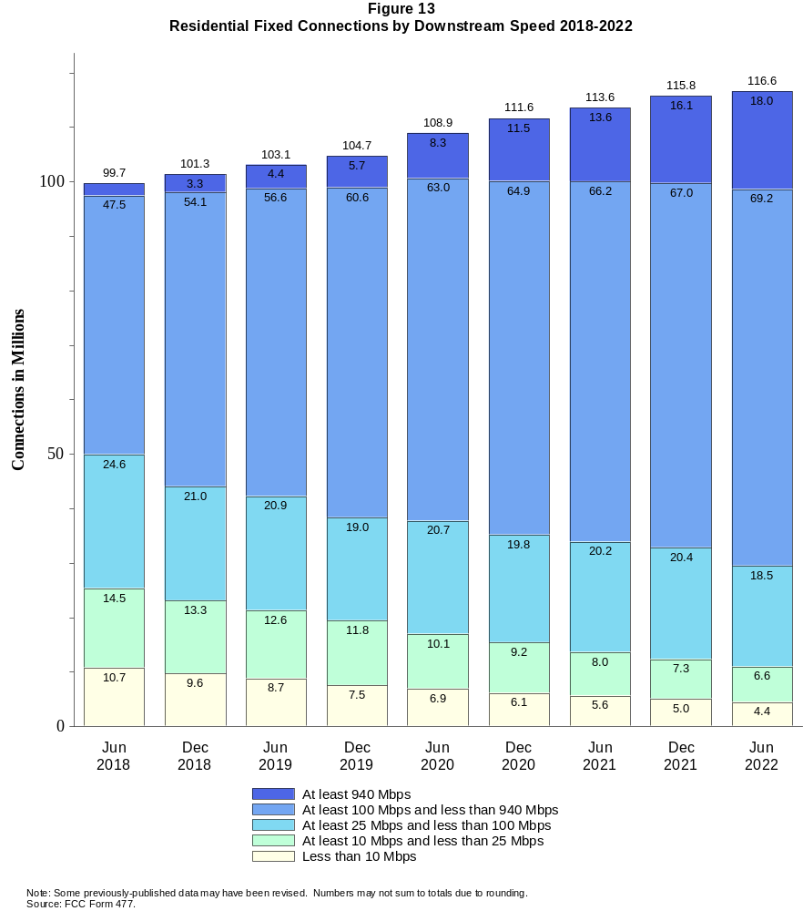

Figure 14
Distribution of Fixed Connections over 200 kbps in at Least One Direction as of June 30, 2022

 | Downstream Speed
Upstream Speed | Less than 10 Mbps | At least 10 Mbps  and less than 25 Mbps | At least 25 Mbps  and less than 100 Mbps | At least 100 Mbps  and less than 940 Mbps | At least 940 Mbps | Total
Less than 1 Mbps | 3,194 | 819 | 1 | # | # | 4,014
At least 1 Mbps & Less than 3 Mbps | 1,813 | 4,853 | 723 | 1 | # | 7,390
At least 3 Mbps & Less than 20 Mbps | 153 | 1,689 | 17,028 | 40,017 | 117 | 59,004
At least 20 Mbps & Less than 500 Mbps | 3 | 53 | 3,051 | 31,449 | 8,047 | 42,603
At least 500 Mbps | # | 0 | # | 2,478 | 10,873 | 13,351
Total | 5,163 | 7,414 | 20,803 | 73,945 | 19,037 | 126,362

Percentages

Less than 1 Mbps | 2.5 | 0.6 | 0.0 | 0.0 | 0.0 | 3.2
At least 1 Mbps & Less than 3 Mbps | 1.4 | 3.8 | 0.6 | 0.0 | 0.0 | 5.8
At least 3 Mbps & Less than 20 Mbps | 0.1 | 1.3 | 13.5 | 31.7 | 0.1 | 46.7
At least 20 Mbps & Less than 500 Mbps | 0.0 | 0.0 | 2.4 | 24.9 | 6.4 | 33.7
At least 500 Mbps | 0.0 | 0.0 | 0.0 | 2.0 | 8.6 | 10.6
Total | 4.1 | 5.9 | 16.5 | 58.5 | 15.1 | 100.0
# = Rounds to zero.
Note: Numbers may not sum to totals due to rounding.
Source: FCC Form 477.

Figure 15
Distribution of Residential Fixed Connections over 200 kbps in at Least One Direction as of June 30, 2022

 | Downstream Speed
Upstream Speed | Less than 10 Mbps | At least 10 Mbps  and less than 25 Mbps | At least 25 Mbps  and less than 100 Mbps | At least 100 Mbps  and less than 940 Mbps | At least 940 Mbps | Total
Less than 1 Mbps | 2,590 | 751 | # | # | # | 3,342
At least 1 Mbps & Less than 3 Mbps | 1,634 | 4,299 | 667 | 1 | # | 6,601
At least 3 Mbps & Less than 20 Mbps | 130 | 1,510 | 15,217 | 38,031 | 114 | 55,002
At least 20 Mbps & Less than 500 Mbps | 3 | 24 | 2,623 | 28,724 | 7,774 | 39,147
At least 500 Mbps | 0 | 0 | # | 2,396 | 10,126 | 12,522
Total | 4,357 | 6,584 | 18,507 | 69,152 | 18,014 | 116,615

Percentages

Less than 1 Mbps | 2.2 | 0.6 | 0.0 | 0.0 | 0.0 | 2.9
At least 1 Mbps & Less than 3 Mbps | 1.4 | 3.7 | 0.6 | 0.0 | 0.0 | 5.7
At least 3 Mbps & Less than 20 Mbps | 0.1 | 1.3 | 13.0 | 32.6 | 0.1 | 47.2
At least 20 Mbps & Less than 500 Mbps | 0.0 | 0.0 | 2.2 | 24.6 | 6.7 | 33.6
At least 500 Mbps | 0.0 | 0.0 | 0.0 | 2.1 | 8.7 | 10.7
Total | 3.7 | 5.6 | 15.9 | 59.3 | 15.4 | 100.0
# = Rounds to zero.
Note: Numbers may not sum to totals due to rounding.
Source: FCC Form 477.

Figure 16
Connections over 200 kbps in at Least One Direction by Technology 2018-2022
(in thousands)

 | 2018 |  | 2019 |  | 2020 |  | 2021 |  | 2022
Technology | Jun | Dec | Jun | Dec | Jun | Dec | Jun | Dec | Jun
Total | 428,980 | 451,060 | 459,350 | 466,320 | 480,200 | 490,890 | 500,260 | 510,200 | 517,046
Mobile | 319,780 | 340,280 | 346,600 | 352,010 | 361,740 | 369,640 | 376,840 | 384,420 | 390,684
Fixed | 109,210 | 110,780 | 112,740 | 114,310 | 118,460 | 121,250 | 123,430 | 125,780 | 126,362
Copper Wire¹ | 23,710 | 22,953 | 21,681 | 20,755 | 20,174 | 19,327 | 18,620 | 17,412 | 15,652
Coaxial Cable | 67,163 | 68,882 | 70,750 | 72,516 | 75,986 | 77,909 | 79,330 | 80,232 | 80,022
Optical Carrier | 14,982 | 15,492 | 16,748 | 17,376 | 18,459 | 19,945 | 21,120 | 23,338 | 24,997
Satellite | 1,939 | 1,971 | 1,984 | 1,975 | 1,993 | 1,931 | 1,910 | 1,873 | 2,031
Fixed Wireless | 1,414 | 1,485 | 1,580 | 1,687 | 1,853 | 2,140 | 2,445 | 2,923 | 3,659
Licensed | - | - | - | - | - | - | - | - | 1,953
Unlicensed | - | - | - | - | - | - | - | - | 1,707
¹ Power Line and Other are summarized with Copper Wire for confidentiality reasons. See Technical Notes at the end of the report for a description of FCC
Form 477 technology categories and other reporting requirements.
* = Data withheld for confidentiality reasons. # = Rounds to zero. - = Data was not collected.
Note: We believe mobile connections remain underreported by as much as 2% through June 2018 due to inadequate accounting of connections sold by mobile
virtual network operators (MVNOs). Some previously-published data may have been revised. Numbers may not sum to totals due to rounding.
Source: FCC Form 477.

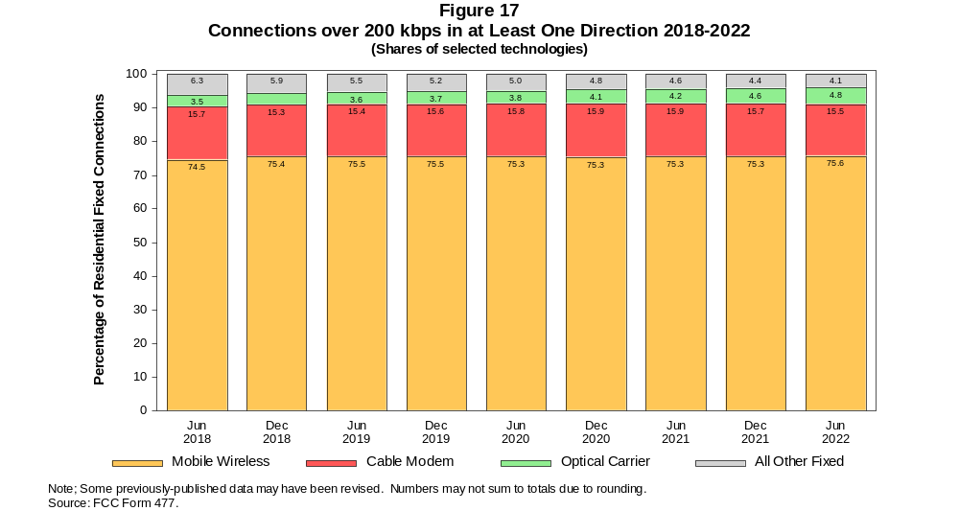

Figure 18
Residential Connections over 200 kbps in at Least One Direction by Technology 2018-2022
(in thousands)

 | 2018 |  | 2019 |  | 2020 |  | 2021 |  | 2022
Technology | Jun | Dec | Jun | Dec | Jun | Dec | Jun | Dec | Jun
Total | 358,850 | 378,290 | 383,620 | 388,360 | 403,230 | 407,650 | 415,260 | 436,580 | 441,672
Mobile | 259,110 | 276,940 | 280,490 | 283,640 | 294,300 | 296,030 | 301,680 | 320,780 | 325,057
Fixed | 99,742 | 101,350 | 103,130 | 104,720 | 108,920 | 111,620 | 113,580 | 115,790 | 116,615
Copper Wire¹ | 20,753 | 20,206 | 19,041 | 18,237 | 17,718 | 16,983 | 16,344 | 15,269 | 13,985
Coaxial Cable | 62,318 | 63,813 | 65,457 | 67,141 | 70,710 | 72,543 | 73,844 | 74,599 | 74,441
Optical Carrier | 13,661 | 14,205 | 15,410 | 16,011 | 16,986 | 18,384 | 19,414 | 21,531 | 22,952
Satellite | 1,751 | 1,787 | 1,805 | 1,795 | 1,815 | 1,752 | 1,728 | 1,692 | 1,841
Fixed Wireless | 1,260 | 1,338 | 1,421 | 1,535 | 1,694 | 1,959 | 2,251 | 2,701 | 3,395
Licensed | - | - | - | - | - | - | - | - | 1,839
Unlicensed | - | - | - | - | - | - | - | - | 1,555
¹ Power Line and Other are summarized with Copper Wire for confidentiality reasons. See Technical Notes at the end of the report for a description of FCC
Form 477 technology categories and other reporting requirements.
* = Data withheld for confidentiality reasons. # = Rounds to zero. - = Data was not collected.
Note: We believe mobile connections remain underreported by as much as 2% through June 2018 due to inadequate accounting of connections sold by mobile
virtual network operators (MVNOs). Some previously-published data may have been revised. Numbers may not sum to totals due to rounding.
Source: FCC Form 477.

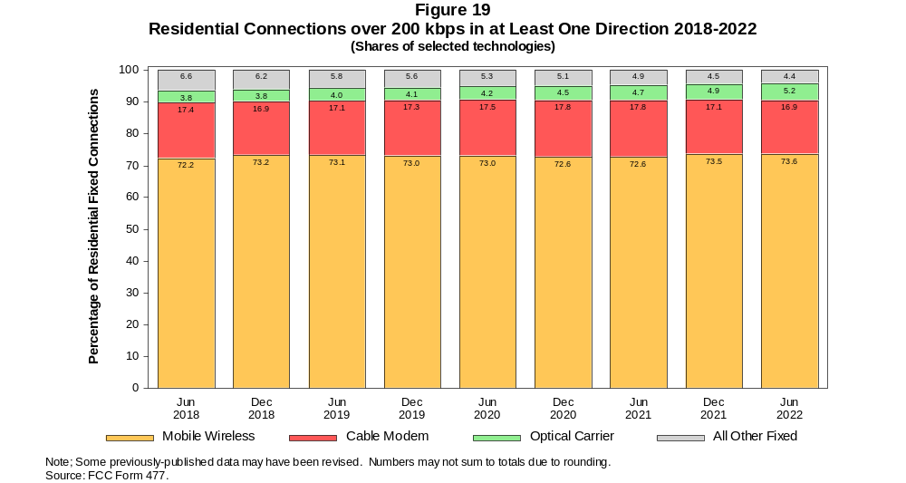

Figure 20
Fixed Connections at Least 10 Mbps Downstream and 1 Mbps Upstream by Technology 2018-2022
(in thousands)

 | 2018 |  | 2019 |  | 2020 |  | 2021 |  | 2022
Technology | Jun | Dec | Jun | Dec | Jun | Dec | Jun | Dec | Jun
Total | 94,148 | 97,302 | 100,480 | 103,610 | 109,180 | 112,450 | 115,770 | 118,770 | 120,380
Copper Wire¹ | 12,110 | 12,335 | 12,094 | 12,011 | 12,735 | 12,086 | 12,347 | 11,681 | 10,690
Coaxial Cable | 65,807 | 67,716 | 69,704 | 71,934 | 75,391 | 77,513 | 79,035 | 79,956 | 79,676
Optical Carrier | 13,988 | 14,815 | 16,078 | 16,854 | 18,008 | 19,555 | 20,813 | 23,058 | 24,833
Satellite | 1,595 | 1,677 | 1,726 | 1,737 | 1,778 | 1,727 | 1,717 | 1,700 | 1,863
Fixed Wireless | 649 | 759 | 879 | 1,078 | 1,263 | 1,564 | 1,860 | 2,379 | 3,318
Licensed | - | - | - | - | - | - | - | - | 1,906
Unlicensed | - | - | - | - | - | - | - | - | 1,411
¹ Power Line and Other are summarized with Copper Wire for confidentiality reasons. See Technical Notes at the end of the report for a description of FCC
Form 477 technology categories and other reporting requirements.
* = Data withheld for confidentiality reasons. # = Rounds to zero. - = Data was not collected.
Note: Some previously-published data may have been revised. Numbers may not sum to totals due to rounding.
Source: FCC Form 477.

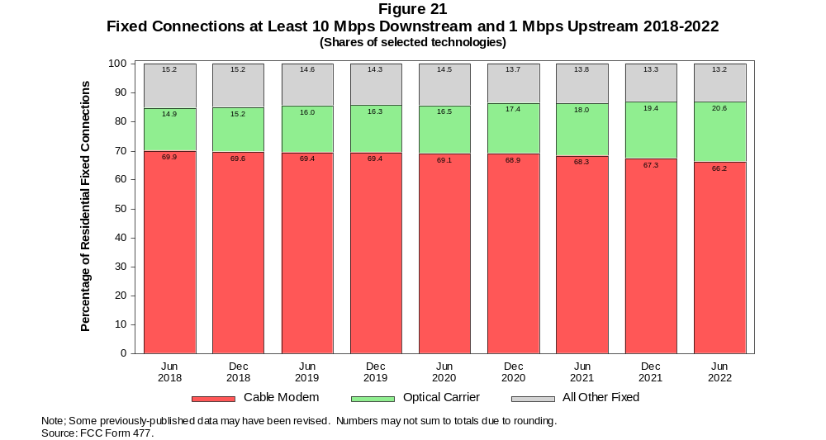

Figure 22
Residential Fixed Connections at Least 10 Mbps Downstream and 1 Mbps Upstream by Technology 2018-2022
(in thousands)

 | 2018 |  | 2019 |  | 2020 |  | 2021 |  | 2022
Technology | Jun | Dec | Jun | Dec | Jun | Dec | Jun | Dec | Jun
Total | 86,959 | 89,873 | 92,714 | 95,665 | 101,220 | 104,200 | 107,210 | 109,980 | 111,506
Copper Wire¹ | 10,930 | 11,143 | 10,871 | 10,754 | 11,440 | 10,818 | 11,066 | 10,441 | 9,658
Coaxial Cable | 61,141 | 62,810 | 64,556 | 66,691 | 70,299 | 72,215 | 73,611 | 74,386 | 74,147
Optical Carrier | 12,739 | 13,589 | 14,800 | 15,536 | 16,581 | 18,042 | 19,145 | 21,286 | 22,815
Satellite | 1,575 | 1,655 | 1,702 | 1,708 | 1,745 | 1,691 | 1,676 | 1,656 | 1,806
Fixed Wireless | 574 | 676 | 784 | 975 | 1,151 | 1,434 | 1,714 | 2,206 | 3,080
Licensed | - | - | - | - | - | - | - | - | 1,797
Unlicensed | - | - | - | - | - | - | - | - | 1,283
¹ Power Line and Other are summarized with Copper Wire for confidentiality reasons. See Technical Notes at the end of the report for a description of FCC
Form 477 technology categories and other reporting requirements.
* = Data withheld for confidentiality reasons. # = Rounds to zero. - = Data was not collected.
Note: Some previously-published data may have been revised. Numbers may not sum to totals due to rounding.
Source: FCC Form 477.

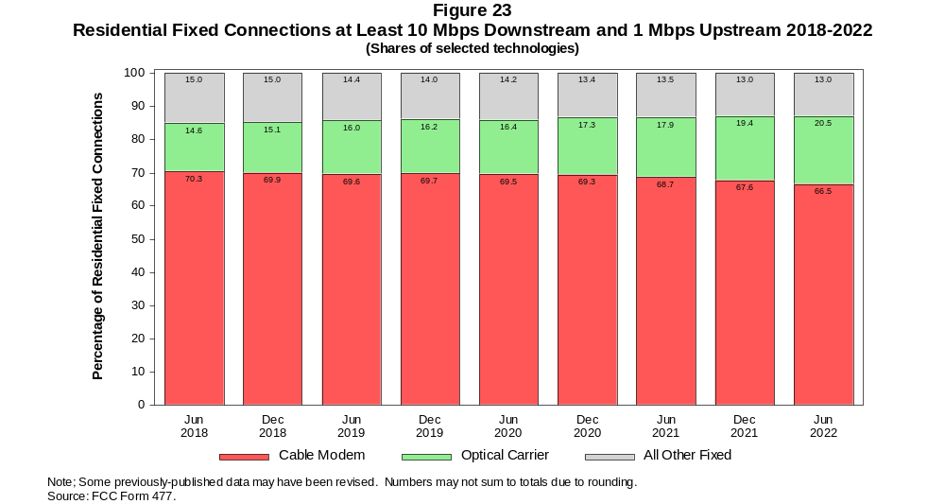

Figure 24
Fixed Connections at Least 25 Mbps Downstream and 3 Mbps Upstream by Technology 2018-2022
(in thousands)

 | 2018 |  | 2019 |  | 2020 |  | 2021 |  | 2022
Technology | Jun | Dec | Jun | Dec | Jun | Dec | Jun | Dec | Jun
Total | 78,995 | 82,965 | 86,763 | 90,490 | 97,000 | 101,630 | 106,790 | 110,630 | 113,060
Copper Wire¹ | * | * | * | * | * | * | 6,688 | 6,538 | 6,014
Coaxial Cable | 60,858 | 62,880 | 64,938 | 67,171 | 71,856 | 74,169 | 77,502 | 78,656 | 78,598
Optical Carrier | 12,609 | 13,605 | 14,902 | 15,866 | 17,091 | 18,840 | 20,171 | 22,459 | 24,295
Satellite | * | * | * | * | * | * | 1,328 | 1,353 | 1,552
Fixed Wireless | 222 | 267 | 343 | 468 | 571 | 805 | 1,105 | 1,620 | 2,601
Licensed | - | - | - | - | - | - | - | - | 1,796
Unlicensed | - | - | - | - | - | - | - | - | 805
¹ Power Line and Other are summarized with Copper Wire for confidentiality reasons. See Technical Notes at the end of the report for a description of FCC
Form 477 technology categories and other reporting requirements.
* = Data withheld for confidentiality reasons. # = Rounds to zero. - = Data was not collected.
Note: Some previously-published data may have been revised. Numbers may not sum to totals due to rounding.
Source: FCC Form 477.

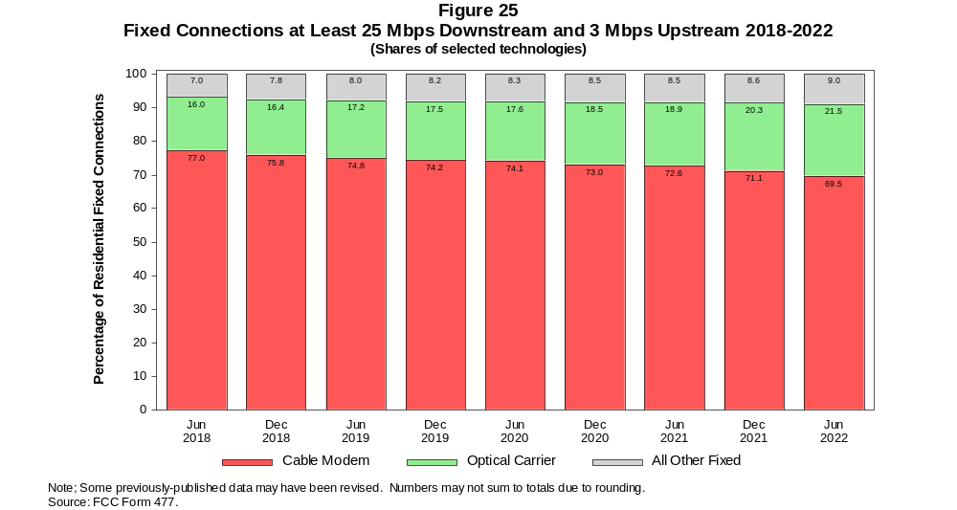

Figure 26
Residential Fixed Connections at Least 25 Mbps Downstream and 3 Mbps Upstream by Technology 2018-2022
(in thousands)

 | 2018 |  | 2019 |  | 2020 |  | 2021 |  | 2022
Technology | Jun | Dec | Jun | Dec | Jun | Dec | Jun | Dec | Jun
Total | 73,283 | 76,873 | 80,272 | 83,740 | 90,185 | 94,451 | 99,254 | 102,800 | 105,005
Copper Wire¹ | * | * | * | * | * | * | 6,068 | 5,930 | 5,515
Coaxial Cable | 56,619 | 58,342 | 60,125 | 62,231 | 67,017 | 69,098 | 72,268 | 73,262 | 73,213
Optical Carrier | 11,569 | 12,546 | 13,780 | 14,690 | 15,796 | 17,445 | 18,615 | 20,795 | 22,365
Satellite | * | * | * | * | * | * | 1,288 | 1,311 | 1,497
Fixed Wireless | 192 | 234 | 299 | 415 | 512 | 727 | 1,015 | 1,506 | 2,414
Licensed | - | - | - | - | - | - | - | - | 1,697
Unlicensed | - | - | - | - | - | - | - | - | 717
¹ Power Line and Other are summarized with Copper Wire for confidentiality reasons. See Technical Notes at the end of the report for a description of FCC
Form 477 technology categories and other reporting requirements.
* = Data withheld for confidentiality reasons. # = Rounds to zero. - = Data was not collected.
Note: Some previously-published data may have been revised. Numbers may not sum to totals due to rounding.
Source: FCC Form 477.

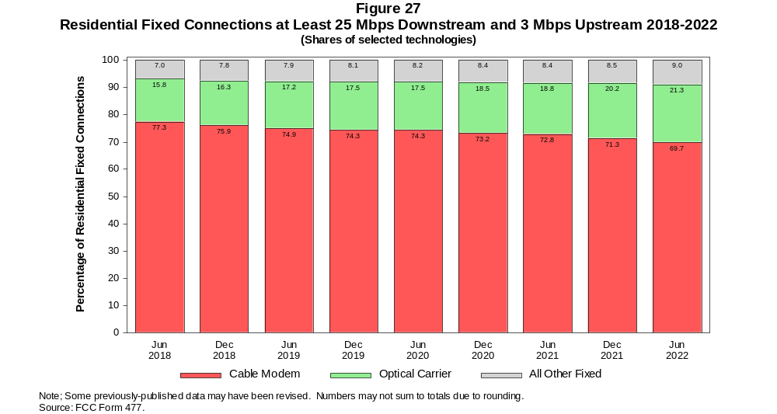

Figure 28
Fixed Connections at Least 100 Mbps Downstream and 20 Mbps Upstream by Technology 2018-2022
(in thousands)

 | 2018 |  | 2019 |  | 2020 |  | 2021 |  | 2022
Technology | Jun | Dec | Jun | Dec | Jun | Dec | Jun | Dec | Jun
Total | 14,646 | 18,750 | 22,236 | 25,621 | 29,570 | 34,493 | 38,563 | 43,352 | 52,848
Copper Wire¹ | 238 | 404 | 566 | * | * | * | * | * | *
Coaxial Cable | 8,352 | 9,466 | 11,426 | 13,088 | 15,496 | 18,420 | 20,924 | 23,298 | 29,955
Optical Carrier | 6,000 | 8,815 | 10,146 | 11,634 | 13,086 | 14,933 | 16,373 | 18,705 | 20,993
Satellite | 0 | 0 | 0 | * | * | * | * | * | *
Fixed Wireless | 56 | 65 | 97 | 119 | 116 | 143 | 180 | 239 | 499
Licensed | - | - | - | - | - | - | - | - | 301
Unlicensed | - | - | - | - | - | - | - | - | 198
¹ Power Line and Other are summarized with Copper Wire for confidentiality reasons. See Technical Notes at the end of the report for a description of FCC
Form 477 technology categories and other reporting requirements.
* = Data withheld for confidentiality reasons. # = Rounds to zero. - = Data was not collected.
Note: Some previously-published data may have been revised. Numbers may not sum to totals due to rounding.
Source: FCC Form 477.

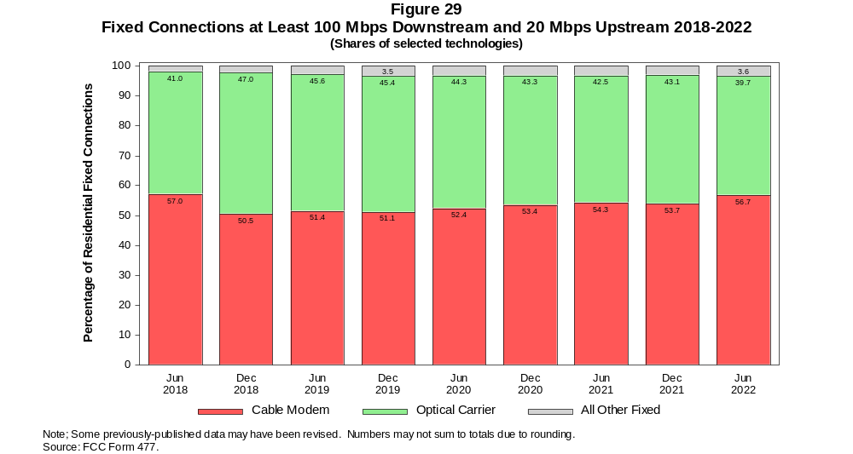

Figure 30
Residential Fixed Connections at Least 100 Mbps Downstream and 20 Mbps Upstream by Technology 2018-2022
(in thousands)

 | 2018 |  | 2019 |  | 2020 |  | 2021 |  | 2022
Technology | Jun | Dec | Jun | Dec | Jun | Dec | Jun | Dec | Jun
Total | 13,170 | 17,101 | 20,338 | 23,485 | 27,179 | 31,773 | 35,456 | 39,921 | 49,020
Copper Wire¹ | 99 | 241 | 371 | * | * | * | * | * | *
Coaxial Cable | 7,491 | 8,512 | 10,312 | 11,883 | 14,157 | 16,843 | 19,128 | 21,298 | 27,829
Optical Carrier | 5,533 | 8,292 | 9,574 | 10,952 | 12,303 | 14,055 | 15,329 | 17,537 | 19,517
Satellite | 0 | 0 | 0 | * | * | * | * | * | *
Fixed Wireless | 47 | 56 | 80 | 102 | 98 | 118 | 158 | 215 | 450
Licensed | - | - | - | - | - | - | - | - | 276
Unlicensed | - | - | - | - | - | - | - | - | 173
¹ Power Line and Other are summarized with Copper Wire for confidentiality reasons. See Technical Notes at the end of the report for a description of FCC
Form 477 technology categories and other reporting requirements.
* = Data withheld for confidentiality reasons. # = Rounds to zero. - = Data was not collected.
Note: Some previously-published data may have been revised. Numbers may not sum to totals due to rounding.
Source: FCC Form 477.

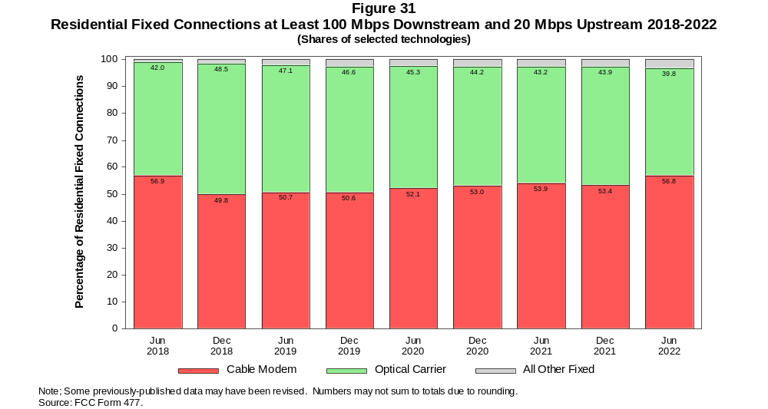

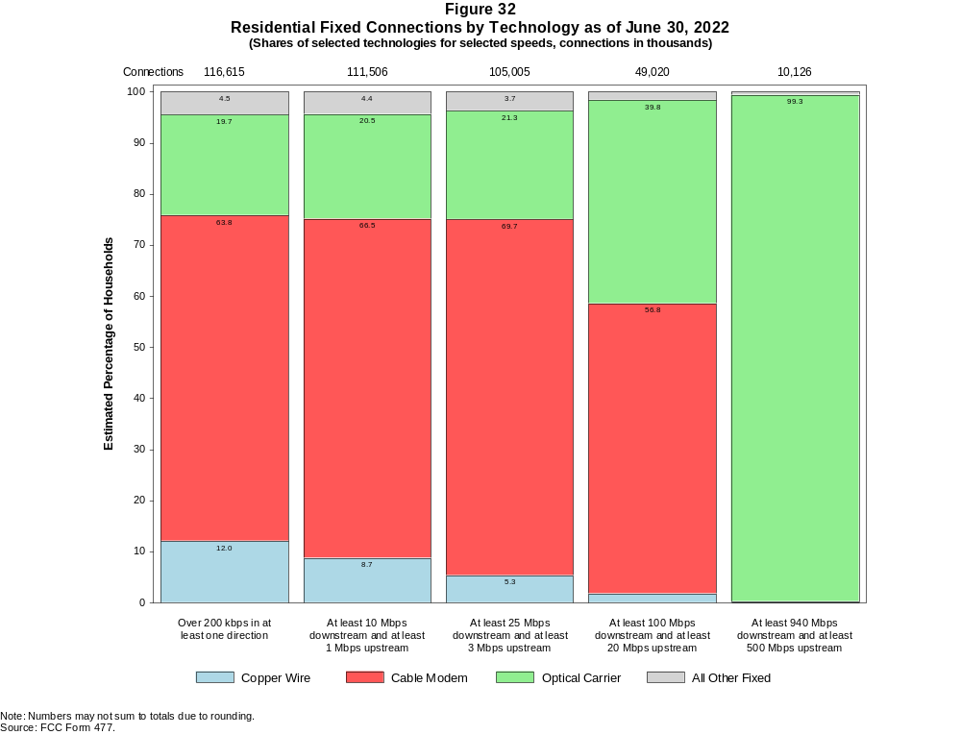

Figure 33
Fixed Connections by Downstream Speed Tier and Technology as of June 30, 2022
(in thousands)

 | Downstream Speed
Technology | Less than  10 Mbps | At least 10 Mbps  and less than  25 Mbps | At least 25 Mbps  and less than  100 Mbps | At least 100 Mbps  and less than  940 Mbps | At least  940 Mbps | Total
Copper Wire | 4,158 | 4,897 | 5,322 | 1,167 | 108 | 15,652
Cable Modem | 339 | 975 | 9,115 | 61,628 | 7,965 | 80,022
Optical Carrier | 155 | 523 | 3,130 | 10,324 | 10,864 | 24,997
Satellite | * | * | * | * | 0 | 2,031
Fixed Wireless | * | * | * | * | 100 | 3,659
Total | 5,163 | 7,414 | 20,803 | 73,945 | 19,037 | 126,362

Percentages

Copper Wire | 3.3 | 3.9 | 4.2 | 0.9 | 0.1 | 12.4
Cable Modem | 0.3 | 0.8 | 7.2 | 48.8 | 6.3 | 63.3
Optical Carrier | 0.1 | 0.4 | 2.5 | 8.2 | 8.6 | 19.8
Satellite | * | * | * | * | 0.0 | 1.6
Fixed Wireless | * | * | * | * | 0.1 | 2.9
Total | 4.1 | 5.9 | 16.5 | 58.5 | 15.1 | 100.0
* = Data withheld for confidentiality reasons. # = Rounds to Zero.
Note: Numbers may not sum to totals due to rounding.
Source: FCC Form 477.

Figure 34
Residential Fixed Connections by Downstream Speed Tier and Technology as of June 30, 2022
(in thousands)

 | Downstream Speed
Technology | Less than  10 Mbps | At least 10 Mbps  and less than  25 Mbps | At least 25 Mbps  and less than  100 Mbps | At least 100 Mbps  and less than  940 Mbps | At least  940 Mbps | Total
Copper Wire | 3,589 | 4,347 | 4,963 | 1,059 | 28 | 13,985
Cable Modem | 289 | 836 | 7,806 | 57,805 | 7,706 | 74,441
Optical Carrier | 130 | 434 | 2,690 | 9,511 | 10,187 | 22,952
Satellite | * | * | * | * | 0 | 1,841
Fixed Wireless | * | * | * | * | 93 | 3,395
Total | 4,357 | 6,584 | 18,507 | 69,152 | 18,014 | 116,615

Percentages

Copper Wire | 3.1 | 3.7 | 4.3 | 0.9 | 0.0 | 12.0
Cable Modem | 0.2 | 0.7 | 6.7 | 49.6 | 6.6 | 63.8
Optical Carrier | 0.1 | 0.4 | 2.3 | 8.2 | 8.7 | 19.7
Satellite | * | * | * | * | 0.0 | 1.6
Fixed Wireless | * | * | * | * | 0.1 | 2.9
Total | 3.7 | 5.6 | 15.9 | 59.3 | 15.4 | 100.0
* = Data withheld for confidentiality reasons. # = Rounds to Zero.
Note: Numbers may not sum to totals due to rounding.
Source: FCC Form 477.

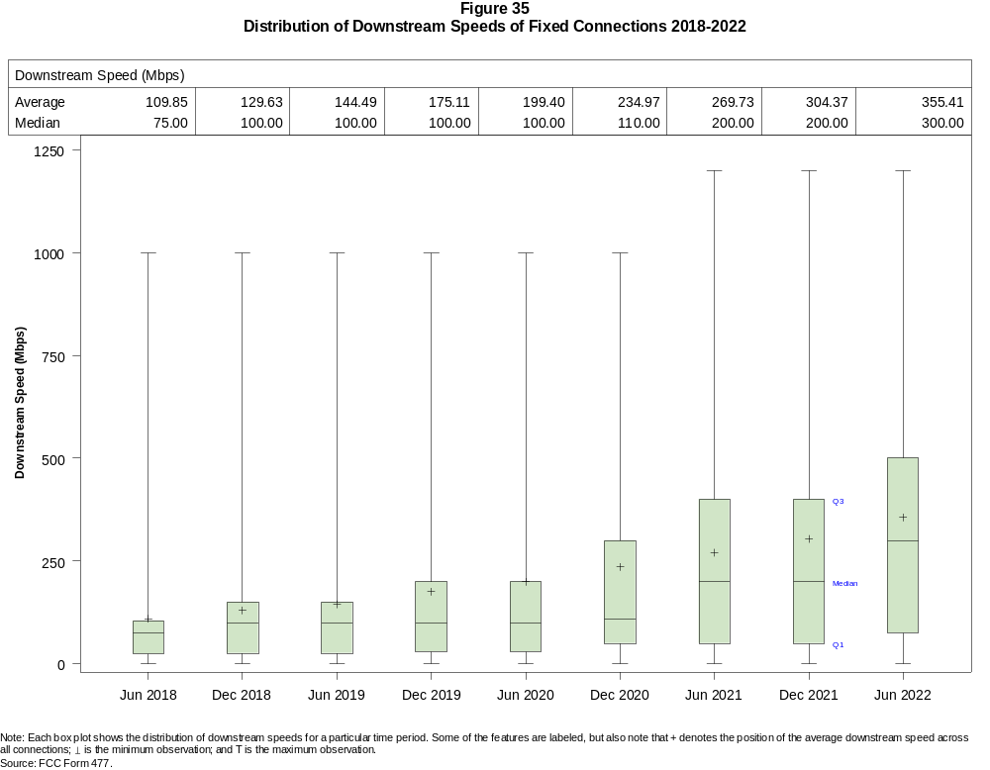

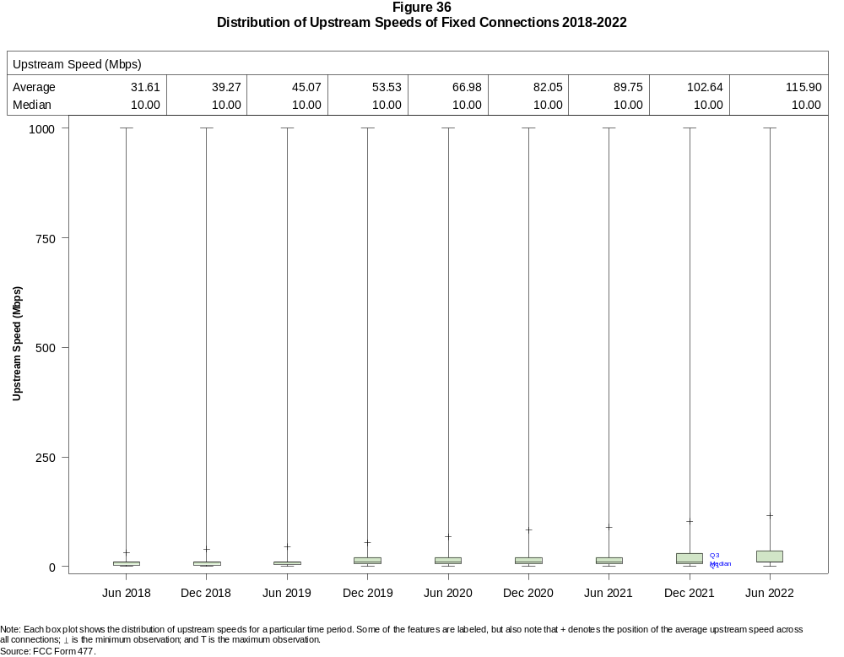

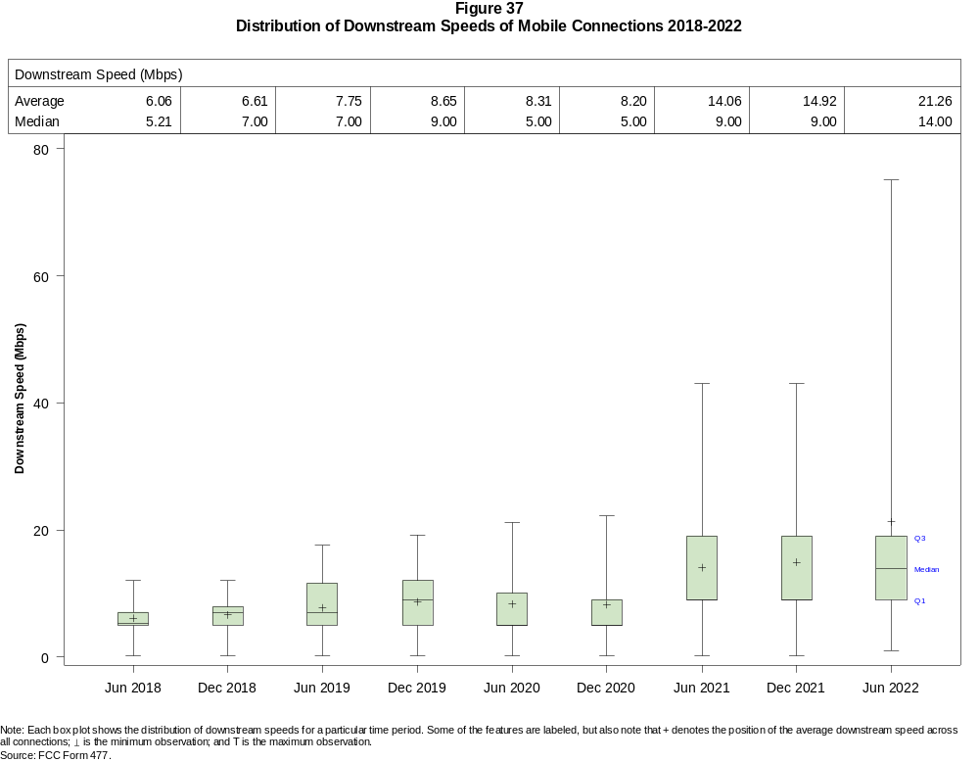

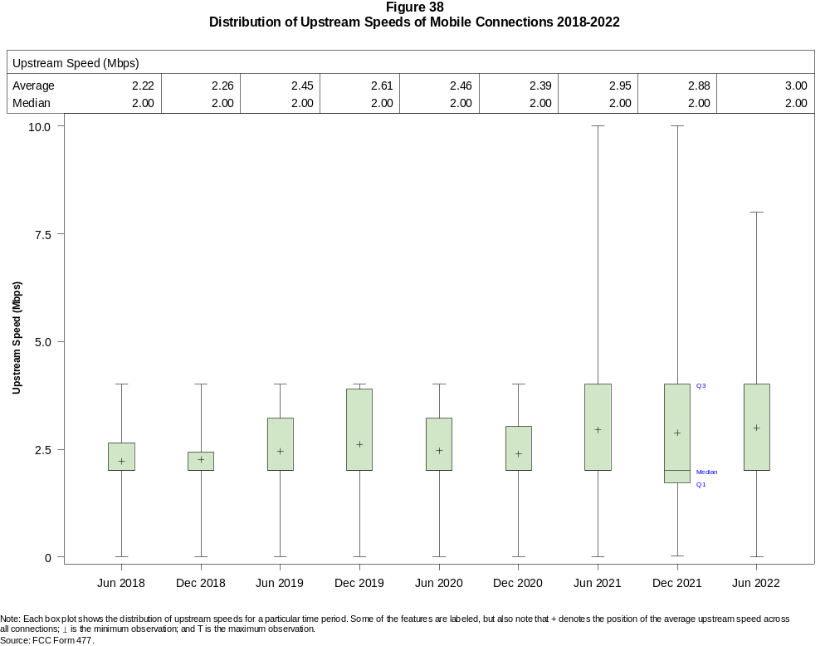

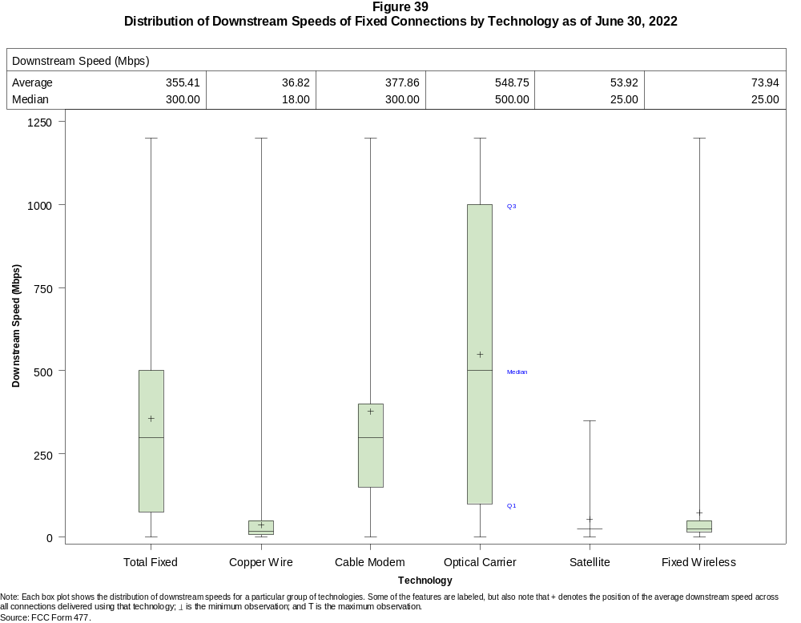

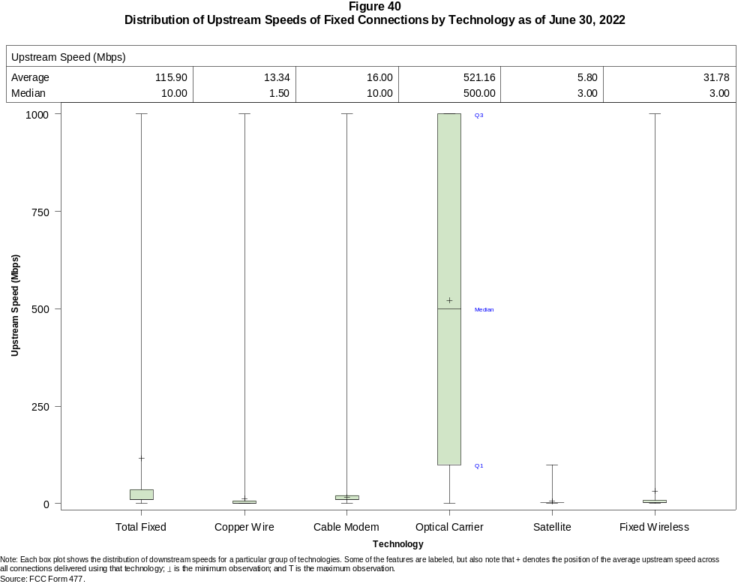

Figure 41
Nationwide Number of Providers of Connections over 200 kbps in at Least One Direction
by Technology 2018-2021

 | 2018 |  | 2019 |  | 2020 |  | 2021 |  | 2022
Technology | Jun | Dec | Jun | Dec | Jun | Dec | Jun | Dec | Jun
Total | 2,113 | 2,215 | 2,224 | 2,248 | 2,281 | 2,382 | 2,392 | 2,384 | 2,242
Mobile | 73 | 71 | 70 | 67 | 64 | 64 | 63 | 62 | 48
Fixed | 2,094 | 2,195 | 2,203 | 2,230 | 2,266 | 2,371 | 2,378 | 2,371 | 2,236
Copper Wire¹ | 868 | 852 | 827 | 803 | 797 | 773 | 755 | 743 | 593
Coaxial Cable | 371 | 381 | 381 | 373 | 365 | 368 | 362 | 352 | 311
Optical Carrier | 1,176 | 1,269 | 1,310 | 1,331 | 1,380 | 1,442 | 1,477 | 1,505 | 1,473
Satellite | 5 | 5 | 5 | 5 | 5 | 6 | 6 | 5 | 4
Fixed Wireless | 1,176 | 1,239 | 1,249 | 1,281 | 1,313 | 1,397 | 1,383 | 1,359 | 1,231
Licensed | - | - | - | - | - | - | - | - | 298
Unlicensed | - | - | - | - | - | - | - | - | 1,127
¹ Prior to June 2022, Power Line is summarized with Other for confidentiality reasons.
* = 1 - 3 providers. - = Data not collected.
Note: Multiple FCC Form 477 filers within a holding company structure count as one provider. Some previously-published data may have been revised.
Source: FCC Form 477.

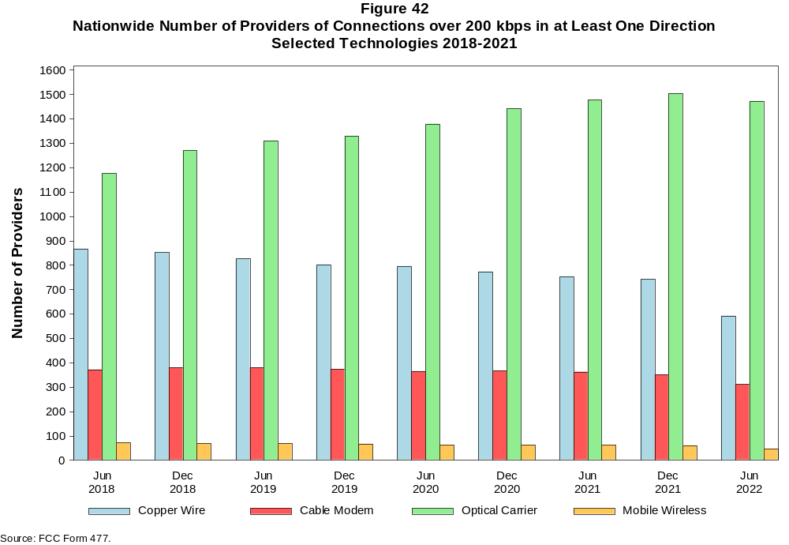

Figure 43
Residential Fixed Connections and Households by State as of June 30, 2022
(Connections and households, in thousands)

 |  | At least 200 kbps in  at least One Direction |  | At least 10 Mbps Down  and 1 Mbps Up |  | At least 25 Mbps Down  and 3 Mbps Up |  | At least 100 Mbps Down  and 20 Mbps Up |  | At least 940 Mbps Down  and 500 Mbps Up
State | Households | Connections | Subscribership  Ratio | Connections | Subscribership  Ratio | Connections | Subscribership  Ratio | Connections | Subscribership  Ratio | Connections | Subscribership  Ratio
Alabama | 1,903 | 1,664 | 0.87 | 1,539 | 0.81 | 1,415 | 0.74 | 617 | 0.32 | 149 | 0.08
Alaska | 261 | 231 | 0.89 | 217 | 0.83 | 170 | 0.65 | * | * | * | *
American Samoa | 10 | * | * | * | * | * | * | 0 | 0.00 | 0 | 0.00
Arizona | 2,684 | 2,522 | 0.94 | 2,385 | 0.89 | 2,200 | 0.82 | 636 | 0.24 | 96 | 0.04
Arkansas | 1,158 | 966 | 0.83 | 866 | 0.75 | 758 | 0.65 | 348 | 0.30 | 67 | 0.06
California | 13,218 | 12,661 | 0.96 | 12,319 | 0.93 | 11,695 | 0.88 | 4,603 | 0.35 | 701 | 0.05
Colorado | 2,228 | 2,233 | 1.00 | 2,147 | 0.96 | 2,005 | 0.90 | 699 | 0.31 | 155 | 0.07
Connecticut | 1,397 | 1,292 | 0.92 | 1,263 | 0.90 | 1,186 | 0.85 | 656 | 0.47 | 36 | 0.03
Delaware | 381 | 404 | 1.06 | 398 | 1.04 | 396 | 1.04 | 238 | 0.62 | * | *
District of Columbia | 310 | 275 | 0.89 | 271 | 0.87 | 269 | 0.87 | 170 | 0.55 | * | *
Florida | 8,157 | 8,456 | 1.04 | 8,116 | 0.99 | 7,826 | 0.96 | 3,514 | 0.43 | 547 | 0.07
Georgia | 3,885 | 3,652 | 0.94 | 3,469 | 0.89 | 3,249 | 0.84 | 1,710 | 0.44 | 429 | 0.11
Guam | 42 | 37 | 0.89 | 35 | 0.83 | 27 | 0.64 | * | * | 0 | 0.00
Hawaii | 478 | 488 | 1.02 | 479 | 1.00 | * | * | * | * | * | *
Idaho | 657 | 621 | 0.94 | 560 | 0.85 | 455 | 0.69 | 280 | 0.43 | 38 | 0.06
Illinois | 4,930 | 4,325 | 0.88 | 4,138 | 0.84 | 3,871 | 0.79 | 1,763 | 0.36 | 173 | 0.04
Indiana | 2,623 | 2,325 | 0.89 | 2,181 | 0.83 | 2,015 | 0.77 | 947 | 0.36 | 181 | 0.07
Iowa | 1,276 | 1,083 | 0.85 | 1,000 | 0.78 | 891 | 0.70 | 431 | 0.34 | 57 | 0.04
Kansas | 1,140 | 998 | 0.88 | 944 | 0.83 | 869 | 0.76 | 404 | 0.35 | 134 | 0.12
Kentucky | 1,748 | 1,557 | 0.89 | 1,445 | 0.83 | 1,316 | 0.75 | 602 | 0.34 | 108 | 0.06
Louisiana | 1,749 | 1,472 | 0.84 | 1,373 | 0.78 | 1,249 | 0.71 | 489 | 0.28 | 103 | 0.06
Maine | 571 | 592 | 1.04 | 555 | 0.97 | 487 | 0.85 | 104 | 0.18 | 2 | 0.00
Maryland | 2,294 | 2,205 | 0.96 | 2,167 | 0.94 | 2,142 | 0.93 | 1,374 | 0.60 | * | *
Massachusetts | 2,714 | 2,644 | 0.97 | 2,598 | 0.96 | 2,583 | 0.95 | 1,461 | 0.54 | 322 | 0.12
Michigan | 3,977 | 3,591 | 0.90 | 3,426 | 0.86 | 3,228 | 0.81 | 1,159 | 0.29 | 84 | 0.02
Minnesota | 2,229 | 2,023 | 0.91 | 1,918 | 0.86 | 1,761 | 0.79 | 600 | 0.27 | 76 | 0.03
Mississippi | 1,109 | 893 | 0.81 | 805 | 0.73 | 678 | 0.61 | 370 | 0.33 | 126 | 0.11
Missouri | 2,434 | 2,122 | 0.87 | 1,953 | 0.80 | 1,758 | 0.72 | 864 | 0.35 | 228 | 0.09
Montana | 436 | 410 | 0.94 | 376 | 0.86 | 328 | 0.75 | 82 | 0.19 | 9 | 0.02
Nebraska | 767 | 683 | 0.89 | 651 | 0.85 | 603 | 0.79 | 246 | 0.32 | 44 | 0.06

Figure 43 - Continued
Residential Fixed Connections and Households by State as of June 30, 2022
(Connections and households, in thousands)

 |  | At least 200 kbps in  at least One Direction |  | At least 10 Mbps Down  and 1 Mbps Up |  | At least 25 Mbps Down  and 3 Mbps Up |  | At least 100 Mbps Down  and 20 Mbps Up |  | At least 940 Mbps Down  and 500 Mbps Up
State | Households | Connections | Subscribership  Ratio | Connections | Subscribership  Ratio | Connections | Subscribership  Ratio | Connections | Subscribership  Ratio | Connections | Subscribership  Ratio
Nevada | 1,142 | 1,104 | 0.97 | 1,060 | 0.93 | 1,011 | 0.89 | 308 | 0.27 | 49 | 0.04
New Hampshire | 540 | 561 | 1.04 | 541 | 1.00 | 517 | 0.96 | 281 | 0.52 | 5 | 0.01
New Jersey | 3,397 | 3,157 | 0.93 | 3,115 | 0.92 | 3,092 | 0.91 | 2,310 | 0.68 | * | *
New Mexico | 798 | 702 | 0.88 | 638 | 0.80 | 554 | 0.69 | 140 | 0.18 | 12 | 0.01
New York | 7,530 | 6,877 | 0.91 | 6,795 | 0.90 | 6,582 | 0.87 | 3,953 | 0.52 | * | *
North Carolina | 4,035 | 4,021 | 1.00 | 3,754 | 0.93 | 3,567 | 0.88 | 1,550 | 0.38 | 367 | 0.09
North Dakota | 317 | 288 | 0.91 | 282 | 0.89 | 274 | 0.87 | 238 | 0.75 | 8 | 0.02
Northern Mariana Isl | 16 | * | * | * | * | * | * | 0 | 0.00 | 0 | 0.00
Ohio | 4,754 | 4,281 | 0.90 | 4,082 | 0.86 | 3,792 | 0.80 | 1,256 | 0.26 | 114 | 0.02
Oklahoma | 1,504 | 1,261 | 0.84 | 1,173 | 0.78 | 1,055 | 0.70 | 462 | 0.31 | 116 | 0.08
Oregon | 1,658 | 1,575 | 0.95 | 1,492 | 0.90 | 1,406 | 0.85 | 470 | 0.28 | 89 | 0.05
Pennsylvania | 5,148 | 4,645 | 0.90 | 4,422 | 0.86 | 4,340 | 0.84 | 2,453 | 0.48 | * | *
Puerto Rico | 1,197 | 737 | 0.62 | 667 | 0.56 | 506 | 0.42 | 154 | 0.13 | 7 | 0.01
Rhode Island | 427 | 409 | 0.96 | 406 | 0.95 | 405 | 0.95 | 210 | 0.49 | * | *
South Carolina | 1,976 | 1,941 | 0.98 | 1,857 | 0.94 | 1,732 | 0.88 | 798 | 0.40 | 113 | 0.06
South Dakota | 346 | 313 | 0.91 | 307 | 0.89 | 288 | 0.83 | 204 | 0.59 | 4 | 0.01
Tennessee | 2,665 | 2,450 | 0.92 | 2,347 | 0.88 | 2,230 | 0.84 | 1,183 | 0.44 | 344 | 0.13
Texas | 10,239 | 9,725 | 0.95 | 9,409 | 0.92 | 8,813 | 0.86 | 4,658 | 0.45 | 1,257 | 0.12
Utah | 1,034 | 1,015 | 0.98 | 983 | 0.95 | 920 | 0.89 | 400 | 0.39 | 133 | 0.13
Vermont | 263 | 289 | 1.10 | 263 | 1.00 | 221 | 0.84 | 111 | 0.42 | 15 | 0.06
Virgin Islands | 43 | * | * | * | * | * | * | * | * | 0 | 0.00
Virginia | 3,249 | 2,964 | 0.91 | 2,833 | 0.87 | 2,769 | 0.85 | 1,516 | 0.47 | 603 | 0.19
Washington | 2,932 | 2,848 | 0.97 | 2,689 | 0.92 | 2,542 | 0.87 | 839 | 0.29 | 133 | 0.05
West Virginia | 711 | 565 | 0.79 | 503 | 0.71 | 440 | 0.62 | 229 | 0.32 | 7 | 0.01
Wisconsin | 2,402 | 2,201 | 0.92 | 2,055 | 0.86 | 1,839 | 0.77 | 538 | 0.22 | 60 | 0.02
Wyoming | 231 | 217 | 0.94 | 201 | 0.87 | 186 | 0.80 | 49 | 0.21 | 2 | 0.01
Total | 125,319 | 116,615 | 0.93 | 111,506 | 0.89 | 105,005 | 0.84 | 49,020 | 0.39 | 10,126 | 0.08
# = Rounds to Zero; * = Data withheld for confidentiality reasons.
Note: Numbers may not sum to totals due to rounding.
Sources: FCC Form 477 (Connections); 2017-2021 ACS 5-year estimates; Census 2010.

Figure 44
Connections by Type of End User by State as of June 30, 2022
(Connections over 200 kbps in at least one direction, in thousands)

 | Connections |  | Percentages
State | Residential | Business | Residential | Business | Total
Alabama | 6,449 | 1,002 | 86.6 | 13.4 | 7,451
Alaska | 892 | 147 | 85.9 | 14.1 | 1,038
American Samoa | * | * | * | * | *
Arizona | 9,362 | 1,384 | 87.1 | 12.9 | 10,747
Arkansas | 3,823 | 533 | 87.8 | 12.2 | 4,356
California | 53,181 | 9,486 | 84.9 | 15.1 | 62,667
Colorado | 7,530 | 1,472 | 83.6 | 16.4 | 9,002
Connecticut | 4,880 | 891 | 84.6 | 15.4 | 5,772
Delaware | 1,378 | 233 | 85.6 | 14.4 | 1,610
District of Columbia | 1,156 | 697 | 62.4 | 37.6 | 1,853
Florida | 30,781 | 4,709 | 86.7 | 13.3 | 35,490
Georgia | 14,459 | 2,442 | 85.6 | 14.4 | 16,901
Guam | 140 | 61 | 69.8 | 30.2 | 201
Hawaii | 1,904 | 327 | 85.3 | 14.7 | 2,232
Idaho | 2,269 | 334 | 87.2 | 12.8 | 2,603
Illinois | 16,743 | 3,186 | 84.0 | 16.0 | 19,929
Indiana | 8,453 | 1,267 | 87.0 | 13.0 | 9,720
Iowa | 3,905 | 624 | 86.2 | 13.8 | 4,529
Kansas | 3,637 | 546 | 87.0 | 13.0 | 4,183
Kentucky | 5,523 | 835 | 86.9 | 13.1 | 6,358
Louisiana | 6,197 | 862 | 87.8 | 12.2 | 7,059
Maine | 1,735 | 317 | 84.6 | 15.4 | 2,052
Maryland | 8,340 | 1,353 | 86.0 | 14.0 | 9,693
Massachusetts | 9,293 | 1,780 | 83.9 | 16.1 | 11,073
Michigan | 12,845 | 2,208 | 85.3 | 14.7 | 15,053
Minnesota | 7,165 | 1,273 | 84.9 | 15.1 | 8,438
Mississippi | 3,822 | 458 | 89.3 | 10.7 | 4,280
Missouri | 7,813 | 1,306 | 85.7 | 14.3 | 9,119
Montana | 1,352 | 237 | 85.1 | 14.9 | 1,589
Nebraska | 2,415 | 477 | 83.5 | 16.5 | 2,893
Nevada | 4,270 | 571 | 88.2 | 11.8 | 4,842
New Hampshire | 1,771 | 358 | 83.2 | 16.8 | 2,129
New Jersey | 12,566 | 2,255 | 84.8 | 15.2 | 14,820
New Mexico | 2,705 | 396 | 87.2 | 12.8 | 3,101
New York | 27,496 | 5,172 | 84.2 | 15.8 | 32,668
North Carolina | 13,652 | 2,407 | 85.0 | 15.0 | 16,059
North Dakota | 986 | 157 | 86.3 | 13.7 | 1,143
Northern Mariana Isl | * | * | * | * | *
Ohio | 15,192 | 2,653 | 85.1 | 14.9 | 17,844
Oklahoma | 5,030 | 749 | 87.0 | 13.0 | 5,779
Oregon | 5,415 | 0 | 84.4 | 15.6 | 6,415
Pennsylvania | 16,800 | 2,927 | 85.2 | 14.8 | 19,726
Puerto Rico | 4,018 | 333 | 92.3 | 7.7 | 4,351
Rhode Island | 1,461 | 289 | 83.5 | 16.5 | 1,751
South Carolina | 6,641 | 1,056 | 86.3 | 13.7 | 7,697
South Dakota | 1,105 | 161 | 87.3 | 12.7 | 1,266
Tennessee | 9,076 | 1,427 | 86.4 | 13.6 | 10,502
Texas | 40,094 | 6,198 | 86.6 | 13.4 | 46,292
Utah | 3,807 | 768 | 83.2 | 16.8 | 4,575
Vermont | 798 | 192 | 80.6 | 19.4 | 989
Virgin Islands | 118 | 17 | 87.4 | 12.6 | 135
Virginia | 11,184 | 2,189 | 83.6 | 16.4 | 13,373
Washington | 9,994 | 1,875 | 84.2 | 15.8 | 11,869
West Virginia | 2,087 | 305 | 87.3 | 12.7 | 2,391
Wisconsin | 7,183 | 1,332 | 84.4 | 15.6 | 8,515
Wyoming | 728 | 121 | 85.8 | 14.2 | 849
Total | 441,672 | 75,375 | 85.4 | 14.6 | 517,046
* = Data withheld for confidentiality reasons. # = Rounds to Zero.
Note: Numbers may not sum to totals due to rounding.
Source: FCC Form 477.

Figure 45
Connections by Technology by State as of June 30, 2022
(Connections over 200 kbps in at least one direction, in thousands)

State | Copper  Wire¹ | Cable  Modem | Optical  Carrier | Other  Fixed² | Mobile  Wireless | Total
Alabama | 333 | 1,000 | 362 | 101 | 5,654 | 7,451
Alaska | 68 | * | 15 | * | 770 | 1,038
American Samoa | 0 | * | * | * | * | *
Arizona | 477 | 1,829 | 193 | 186 | 8,061 | 10,747
Arkansas | 285 | 465 | 222 | 74 | 3,309 | 4,356
California | 1,901 | 9,573 | 1,819 | 525 | 48,849 | 62,667
Colorado | * | 1,626 | 263 | * | 6,610 | 9,002
Connecticut | * | 1,165 | 96 | * | 4,371 | 5,772
Delaware | * | * | * | 9 | * | 1,610
District of Columbia | * | * | * | 12 | 1,550 | 1,853
Florida | 945 | 6,318 | 1,642 | 211 | 26,375 | 35,490
Georgia | 681 | 2,291 | 864 | 130 | 12,936 | 16,901
Guam | * | * | 2 | * | * | 201
Hawaii | * | * | * | 5 | 1,694 | 2,232
Idaho | 185 | 289 | 93 | 105 | 1,931 | 2,603
Illinois | 762 | 3,199 | 439 | 250 | 15,279 | 19,929
Indiana | 408 | 1,422 | 527 | 140 | 7,223 | 9,720
Iowa | 242 | 492 | 351 | 88 | 3,355 | 4,529
Kansas | 147 | 525 | 320 | 87 | 3,104 | 4,183
Kentucky | 306 | 904 | 396 | 76 | 4,676 | 6,358
Louisiana | 296 | 929 | 275 | 97 | 5,462 | 7,059
Maine | 90 | 503 | 30 | 27 | 1,401 | 2,052
Maryland | * | 1,346 | * | 46 | 7,334 | 9,693
Massachusetts | * | 2,136 | 624 | * | 8,220 | 11,073
Michigan | 569 | 2,835 | 265 | 197 | 11,187 | 15,053
Minnesota | 368 | 1,366 | 328 | 112 | 6,264 | 8,438
Mississippi | 275 | 391 | 240 | 78 | 3,296 | 4,280
Missouri | 457 | 1,133 | 537 | 168 | 6,824 | 9,119
Montana | 84 | 257 | 55 | 60 | 1,133 | 1,589
Nebraska | 115 | 394 | 180 | 54 | 2,150 | 2,893

Figure 45 - Continued
Connections by Technology by State as of June 30, 2022
(Connections over 200 kbps in at least one direction, in thousands)

State | Copper  Wire¹ | Cable  Modem | Optical  Carrier | Other  Fixed² | Mobile  Wireless | Total
Nevada | 135 | * | 113 | * | 3,651 | 4,842
New Hampshire | 51 | * | 58 | * | 1,496 | 2,129
New Jersey | 65 | 2,090 | * | * | 11,402 | 14,820
New Mexico | 197 | 438 | 60 | 60 | 2,346 | 3,101
New York | 155 | 5,024 | 2,192 | 115 | 25,184 | 32,668
North Carolina | 536 | 2,848 | 834 | 148 | 11,694 | 16,059
North Dakota | 16 | 174 | 124 | 7 | 823 | 1,143
Northern Mariana Isl | * | * | * | 0 | * | *
Ohio | 645 | 3,193 | 579 | 179 | 13,249 | 17,844
Oklahoma | 273 | 666 | 296 | 134 | 4,411 | 5,779
Oregon | 188 | 1,159 | 263 | 93 | 4,712 | 6,415
Pennsylvania | 336 | 3,402 | 1,146 | 111 | 14,732 | 19,726
Puerto Rico | * | * | 126 | 83 | 3,558 | 4,351
Rhode Island | * | * | * | 6 | * | 1,751
South Carolina | 287 | 1,296 | 486 | 70 | 5,558 | 7,697
South Dakota | 29 | 201 | 97 | 17 | 922 | 1,266
Tennessee | 309 | 1,451 | 784 | 104 | 7,854 | 10,502
Texas | 1,271 | 5,682 | 2,829 | 707 | 35,803 | 46,292
Utah | 129 | 625 | 243 | 88 | 3,490 | 4,575
Vermont | 79 | * | 63 | * | 652 | 989
Virgin Islands | 0 | * | 0 | * | 103 | 135
Virginia | 180 | 1,770 | 1,258 | 139 | 10,026 | 13,373
Washington | 383 | 2,228 | 284 | 155 | 8,818 | 11,869
West Virginia | * | 423 | 67 | * | 1,738 | 2,391
Wisconsin | 443 | * | 308 | * | 6,138 | 8,515
Wyoming | 38 | 132 | 21 | 51 | 607 | 849
Total | 15,652 | 80,022 | 24,997 | 5,691 | 390,684 | 517,046
* = Data withheld for confidentiality reasons. # = Rounds to Zero.
¹ Other is summarized with Copper Wire for confidentiality reasons.
² Other Fixed consists of Fixed Wireless and Satellite services.
Note: Numbers may not sum to totals due to rounding.
Source: FCC Form 477.

Figure 46
Percentage of Fixed Connections by Downstream Speed by State as of June 30, 2022

 | Over 200 kbps Upstream and
State | % over 200 kbps  Downstream | % at least 10 Mbps  Downstream | % at least 25 Mbps  Downstream | % at least 100 Mbps  Downstream | % at least 940 Mbps  Downstream
Alabama | 99.9 | 93.7 | 85.3 | 67.9 | 11.5
Alaska | 99.8 | 92.8 | 73.9 | * | *
American Samoa | * | * | * | * | *
Arizona | 99.9 | 95.4 | 88.5 | 71.9 | 14.1
Arkansas | 99.9 | 91.5 | 78.9 | 55.1 | 12.2
California | 99.9 | 96.8 | 91.6 | 76.1 | 13.2
Colorado | 99.9 | 96.9 | 90.4 | 70.3 | 18.1
Connecticut | 100.0 | 97.4 | 92.1 | 83.0 | 13.0
Delaware | 100.0 | 98.1 | 97.5 | 84.0 | 26.1
District of Columbia | 100.0 | 97.1 | 96.1 | 84.3 | 25.7
Florida | 99.9 | 96.7 | 92.7 | 74.4 | 11.0
Georgia | 99.6 | 94.8 | 88.8 | 69.4 | 17.6
Guam | 100.0 | 87.2 | 75.3 | 6.4 | *
Hawaii | 100.0 | 97.0 | * | * | *
Idaho | 99.9 | 92.0 | 75.5 | 54.7 | 10.3
Illinois | 100.0 | 95.5 | 89.3 | 65.9 | 11.4
Indiana | 99.8 | 94.5 | 86.7 | 63.8 | 12.4
Iowa | 100.0 | 93.9 | 83.7 | 61.5 | 12.7
Kansas | 100.0 | 95.3 | 86.6 | 67.3 | 20.0
Kentucky | 99.7 | 92.9 | 85.2 | 68.9 | 8.6
Louisiana | 99.8 | 93.7 | 85.0 | 66.2 | 13.2
Maine | 99.7 | 92.6 | 82.9 | 71.3 | 2.8
Maryland | 100.0 | 97.8 | 96.6 | 82.2 | 29.8
Massachusetts | 100.0 | 97.9 | 97.3 | 87.0 | 22.2
Michigan | 99.7 | 95.3 | 89.6 | 68.9 | 7.7
Minnesota | 100.0 | 96.0 | 88.2 | 66.6 | 13.6
Mississippi | 99.8 | 90.2 | 76.4 | 53.3 | 18.8
Missouri | 99.9 | 94.1 | 83.7 | 66.4 | 13.5
Montana | 99.9 | 93.7 | 81.1 | 60.4 | 3.1
Nebraska | 99.9 | 95.8 | 88.4 | 67.2 | 10.3

Figure 46 - Continued
Percentage of Fixed Connections by Downstream Speed by State as of June 30, 2022

 | Over 200 kbps Upstream and
State | % over 200 kbps  Downstream | % at least 10 Mbps  Downstream | % at least 25 Mbps  Downstream | % at least 100 Mbps  Downstream | % at least 940 Mbps  Downstream
Nevada | 100.0 | 97.0 | 92.3 | 79.0 | 15.1
New Hampshire | 99.5 | 94.8 | 91.2 | 81.8 | 13.4
New Jersey | 99.8 | 98.4 | 97.5 | 88.6 | 27.1
New Mexico | 99.9 | 93.0 | 81.0 | 53.6 | 8.0
New York | 99.8 | 98.4 | 95.3 | 87.7 | 17.0
North Carolina | 99.7 | 95.0 | 88.9 | 77.4 | 11.6
North Dakota | 99.9 | 98.1 | 95.0 | 83.7 | 51.9
Northern Mariana Isl | * | * | * | * | *
Ohio | 100.0 | 95.7 | 88.5 | 73.1 | 5.0
Oklahoma | 99.9 | 93.1 | 82.8 | 64.4 | 15.6
Oregon | 99.9 | 95.9 | 89.6 | 70.6 | 14.0
Pennsylvania | 99.9 | 95.7 | 93.3 | 78.1 | 19.7
Puerto Rico | 100.0 | 89.8 | 71.7 | 30.7 | 1.1
Rhode Island | 99.6 | 99.0 | 98.3 | 90.0 | 31.0
South Carolina | 99.9 | 96.1 | 89.5 | 75.8 | 10.4
South Dakota | 99.8 | 98.2 | 94.8 | * | *
Tennessee | 99.8 | 95.9 | 90.7 | 72.6 | 18.2
Texas | 99.9 | 96.8 | 90.4 | 72.9 | 18.1
Utah | 100.0 | 97.2 | 91.3 | 71.3 | 23.3
Vermont | 99.7 | 90.3 | 78.2 | 64.0 | 10.7
Virgin Islands | * | * | * | * | *
Virginia | 99.7 | 96.0 | 93.1 | 80.5 | 29.9
Washington | 99.7 | 95.5 | 89.4 | 72.8 | 16.6
West Virginia | 99.5 | 89.3 | 79.7 | 64.5 | 15.9
Wisconsin | 99.7 | 94.8 | 84.1 | 68.6 | 3.8
Wyoming | 99.9 | 94.2 | 86.2 | 63.3 | 2.3
Total | 99.9 | 95.9 | 90.0 | 73.6 | 15.1
* = Data withheld for confidentiality reasons.
Source: FCC Form 477.

Figure 47
Providers of Connections by Technology by State as of June 30, 2022
(Connections over 200 kbps in at least one direction)

State | Copper  Wire¹ | Cable  Modem | Optical  Carrier | Satellite | Fixed  Wireless | Mobile  Wireless | Unduplicated  Total
Alabama | 20 | 15 | 45 | * | 23 | 6 | 76
Alaska | 13 | * | 17 | * | 15 | 11 | 33
American Samoa | 0 | * | * | 0 | * | * | *
Arizona | 21 | 12 | 38 | * | 43 | 5 | 81
Arkansas | 20 | 13 | 52 | * | 29 | 5 | 83
California | 30 | 22 | 65 | * | 120 | 5 | 176
Colorado | 27 | 10 | 71 | * | 64 | 8 | 116
Connecticut | 5 | 5 | 13 | * | 4 | 4 | 23
Delaware | * | * | 11 | * | 4 | * | 22
District of Columbia | 7 | 4 | 17 | * | 8 | 4 | 29
Florida | 19 | 15 | 50 | * | 35 | 6 | 84
Georgia | 26 | 21 | 77 | * | 25 | 5 | 104
Guam | * | * | 4 | 0 | * | * | 4
Hawaii | 5 | * | 10 | * | 4 | 4 | 17
Idaho | 23 | 13 | 37 | * | 39 | 6 | 67
Illinois | 46 | 13 | 86 | * | 68 | 6 | 140
Indiana | 33 | 9 | 81 | * | 61 | 4 | 121
Iowa | 54 | 31 | 181 | * | 77 | 6 | 223
Kansas | 24 | 18 | 63 | * | 44 | 8 | 93
Kentucky | 17 | 24 | 58 | * | 27 | 5 | 94
Louisiana | 13 | 14 | 31 | * | 26 | 4 | 63
Maine | 11 | 4 | 20 | * | 12 | 5 | 37
Maryland | 11 | 13 | 35 | * | 19 | 5 | 61
Massachusetts | 10 | 6 | 25 | * | 13 | 4 | 46
Michigan | 29 | 19 | 69 | * | 49 | 6 | 117
Minnesota | 36 | 17 | 81 | * | 49 | 5 | 120
Mississippi | 16 | 10 | 39 | * | 14 | 5 | 65
Missouri | 33 | 12 | 80 | * | 65 | 6 | 131
Montana | 18 | 5 | 33 | * | 30 | 6 | 55
Nebraska | 22 | 16 | 50 | * | 42 | 6 | 81

Figure 47 - Continued
Providers of Connections by Technology by State as of June 30, 2022
(Connections over 200 kbps in at least one direction)

State | Copper  Wire¹ | Cable  Modem | Optical  Carrier | Satellite | Fixed  Wireless | Mobile  Wireless | Unduplicated  Total
Nevada | 18 | 7 | 28 | * | 26 | 5 | 58
New Hampshire | 8 | * | 17 | * | 7 | 5 | 28
New Jersey | 13 | 5 | 27 | * | 7 | 4 | 38
New Mexico | 19 | 6 | 36 | * | 43 | 6 | 70
New York | 32 | 11 | 50 | * | 23 | 4 | 79
North Carolina | 22 | 20 | 49 | * | 22 | 6 | 78
North Dakota | 16 | 5 | 29 | * | 10 | 6 | 42
Northern Mariana Isl | * | * | * | 0 | 0 | * | *
Ohio | 35 | 23 | 76 | * | 63 | 4 | 138
Oklahoma | 36 | 8 | 64 | * | 46 | 9 | 106
Oregon | 35 | 11 | 58 | * | 44 | 6 | 93
Pennsylvania | 24 | 23 | 60 | * | 33 | 7 | 105
Puerto Rico | * | * | 17 | * | 37 | 4 | 44
Rhode Island | * | * | 6 | * | * | * | 13
South Carolina | 18 | 12 | 35 | * | 10 | 5 | 51
South Dakota | 16 | 7 | 39 | * | 22 | 8 | 65
Tennessee | 19 | 14 | 66 | * | 29 | 5 | 94
Texas | 64 | 22 | 132 | 4 | 147 | 8 | 232
Utah | 14 | 7 | 31 | * | 35 | 6 | 55
Vermont | 9 | * | 17 | * | 11 | 4 | 32
Virgin Islands | 0 | * | 0 | * | * | 4 | 6
Virginia | 26 | 14 | 56 | * | 28 | 5 | 84
Washington | 26 | 20 | 63 | * | 49 | 6 | 100
West Virginia | 8 | 14 | 24 | * | 23 | 5 | 57
Wisconsin | 35 | 15 | 72 | * | 44 | 6 | 107
Wyoming | 11 | 5 | 22 | * | 22 | 6 | 42
Total | 593 | 311 | 1,473 | 4 | 1,231 | 48 | 2,242
* = 1 to 3 providers.
¹ Other is summarized with Copper Wire for confidentiality reasons.
Note: Numbers may not sum to totals due to rounding.
Source: FCC Form 477.

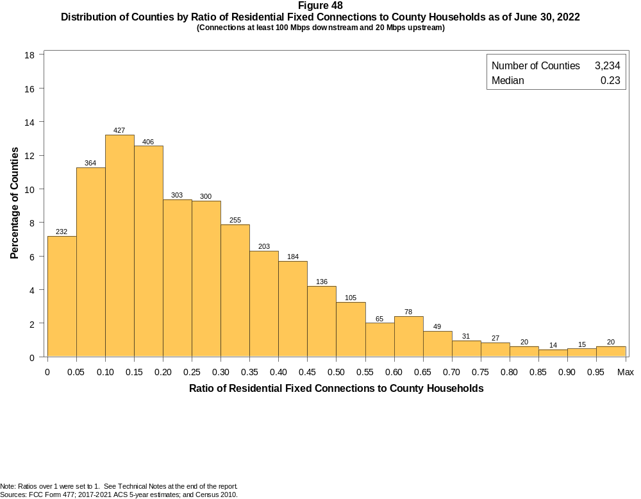
Figure 49
Distribution of Counties by Ratio of Residential Fixed Connections to Households by Technology as of June 30, 2022
(Connections at least 100 Mbps downstream and 20 Mbps upstream)

 | Ratio of Residential Fixed Connections to County Households
Technology | Zero | Greater than 0 and no more than 5% | Greater than 5 and no more than 10% | Greater than 10 and no more than 20% | Greater than 20 and no more than 30% | Greater than 30 and no more than 40% | Greater than 40 and no more than 50% | Greater than 50 and no more than 60% | Greater than 60 and no more than 80% | Greater than 80 and no more than 100% | 100% or more
Total | 0.6 | 6.6 | 11.3 | 25.7 | 18.6 | 14.2 | 9.9 | 5.2 | 5.7 | 1.8 | 0.4
Copper Wire¹ | 59.0 | 34.7 | 4.0 | 2.0 | 0.1 | 0.1 | 0.1 | 0.0 | 0.0 | 0.0 | 0.0
Coaxial Cable | 16.4 | 15.7 | 19.2 | 23.7 | 13.7 | 6.6 | 3.0 | 0.8 | 0.6 | 0.2 | 0.1
Optical Carrier | 10.9 | 38.5 | 14.3 | 16.1 | 7.9 | 5.2 | 2.9 | 1.5 | 1.5 | 1.1 | 0.2
Satellite | 5.2 | 91.6 | 2.4 | 0.6 | 0.1 | 0.0 | 0.0 | 0.0 | 0.0 | 0.0 | 0.0
Fixed Wireless | 56.6 | 42.3 | 0.5 | 0.4 | 0.1 | 0.0 | 0.0 | 0.0 | 0.0 | 0.0 | 0.0
Licensed | 73.8 | 25.9 | 0.2 | 0.1 | 0.0 | 0.0 | 0.0 | 0.0 | 0.0 | 0.0 | 0.0
Unlicensed | 72.3 | 27.0 | 0.3 | 0.3 | 0.1 | 0.0 | 0.0 | 0.0 | 0.0 | 0.0 | 0.0
¹ Other is summarized with Copper Wire for confidentiality reasons.
Note: Numbers may not sum to totals due to rounding.
Sources: FCC Form 477; 2017-2021 ACS 5-year estimates; and Census 2010.

Figure 50
Distribution of Counties by Ratio of Residential Fixed Connections to Households by State as of June 30, 2022
(Connections at least 100 Mbps downstream and 20 Mbps upstream)

 |  | Ratio of Residential Fixed Connections to County Households
State | Counties | Zero | Greater than 0 and no more than 5% | Greater than 5 and no more than 10% | Greater than 10 and no more than 20% | Greater than 20 and no more than 30% | Greater than 30 and no more than 40% | Greater than 40 and no more than 50% | Greater than 50 and no more than 60% | Greater than 60 and no more than 80% | Greater than 80 and no more than 100% | 100% or more
Alabama | 67 | 0 | 6 | 15 | 16 | 11 | 10 | 6 | 1 | 2 | 0 | 0
Alaska | 30 | 9 | 4 | 3 | 1 | 4 | 1 | 2 | 2 | 4 | 0 | 0
American Samoa | 5 | 5 | 0 | 0 | 0 | 0 | 0 | 0 | 0 | 0 | 0 | 0
Arizona | 15 | 0 | 0 | 3 | 4 | 3 | 1 | 4 | 0 | 0 | 0 | 0
Arkansas | 75 | 0 | 9 | 6 | 18 | 19 | 10 | 5 | 5 | 2 | 1 | 0
California | 58 | 0 | 3 | 4 | 8 | 12 | 20 | 9 | 1 | 0 | 1 | 0
Colorado | 64 | 0 | 5 | 6 | 23 | 11 | 13 | 6 | 0 | 0 | 0 | 0
Connecticut | 8 | 0 | 0 | 0 | 0 | 1 | 2 | 4 | 0 | 1 | 0 | 0
Delaware | 3 | 0 | 0 | 0 | 0 | 0 | 0 | 0 | 1 | 2 | 0 | 0
District of Columbia | 1 | 0 | 0 | 0 | 0 | 0 | 0 | 0 | 1 | 0 | 0 | 0
Florida | 67 | 0 | 7 | 7 | 12 | 7 | 11 | 13 | 6 | 4 | 0 | 0
Georgia | 159 | 0 | 10 | 25 | 46 | 20 | 15 | 25 | 11 | 7 | 0 | 0
Guam | 1 | 0 | 1 | 0 | 0 | 0 | 0 | 0 | 0 | 0 | 0 | 0
Hawaii | 5 | 0 | 0 | 1 | 0 | 1 | 1 | 1 | 1 | 0 | 0 | 0
Idaho | 44 | 0 | 3 | 6 | 10 | 11 | 4 | 7 | 0 | 2 | 1 | 0
Illinois | 102 | 0 | 4 | 4 | 26 | 31 | 25 | 9 | 1 | 2 | 0 | 0
Indiana | 92 | 0 | 2 | 4 | 23 | 17 | 29 | 7 | 7 | 3 | 0 | 0
Iowa | 99 | 0 | 1 | 4 | 22 | 36 | 19 | 9 | 7 | 1 | 0 | 0
Kansas | 105 | 0 | 5 | 21 | 35 | 19 | 15 | 3 | 3 | 4 | 0 | 0
Kentucky | 120 | 0 | 5 | 16 | 32 | 24 | 19 | 9 | 10 | 3 | 2 | 0
Louisiana | 64 | 0 | 11 | 14 | 15 | 9 | 7 | 6 | 1 | 1 | 0 | 0
Maine | 16 | 0 | 0 | 0 | 14 | 1 | 1 | 0 | 0 | 0 | 0 | 0
Maryland | 24 | 0 | 0 | 0 | 0 | 3 | 4 | 4 | 4 | 9 | 0 | 0
Massachusetts | 14 | 0 | 0 | 0 | 0 | 1 | 2 | 2 | 3 | 4 | 0 | 2
Michigan | 83 | 0 | 2 | 14 | 40 | 16 | 6 | 3 | 2 | 0 | 0 | 0
Minnesota | 87 | 0 | 2 | 11 | 22 | 22 | 14 | 5 | 7 | 3 | 1 | 0
Mississippi | 82 | 0 | 16 | 9 | 13 | 13 | 14 | 12 | 5 | 0 | 0 | 0
Missouri | 115 | 0 | 20 | 12 | 23 | 23 | 12 | 9 | 5 | 10 | 1 | 0
Montana | 56 | 0 | 5 | 15 | 20 | 3 | 1 | 1 | 2 | 6 | 3 | 0
Nebraska | 93 | 0 | 10 | 7 | 16 | 17 | 21 | 14 | 4 | 2 | 2 | 0

Figure 50 - Continued
Distribution of Counties by Ratio of Residential Fixed Connections to Households by State as of June 30, 2022
(Connections at least 100 Mbps downstream and 20 Mbps upstream)

 |  | Ratio of Residential Fixed Connections to County Households
State | Counties | Zero | Greater than 0 and no more than 5% | Greater than 5 and no more than 10% | Greater than 10 and no more than 20% | Greater than 20 and no more than 30% | Greater than 30 and no more than 40% | Greater than 40 and no more than 50% | Greater than 50 and no more than 60% | Greater than 60 and no more than 80% | Greater than 80 and no more than 100% | 100% or more
Nevada | 17 | 0 | 2 | 3 | 6 | 5 | 1 | 0 | 0 | 0 | 0 | 0
New Hampshire | 10 | 0 | 0 | 0 | 1 | 1 | 2 | 2 | 2 | 1 | 0 | 1
New Jersey | 21 | 0 | 0 | 0 | 0 | 0 | 1 | 3 | 2 | 13 | 1 | 1
New Mexico | 33 | 0 | 5 | 3 | 13 | 2 | 4 | 0 | 0 | 3 | 3 | 0
New York | 62 | 0 | 0 | 2 | 28 | 16 | 2 | 2 | 2 | 7 | 2 | 1
North Carolina | 100 | 0 | 1 | 11 | 30 | 20 | 19 | 10 | 5 | 3 | 1 | 0
North Dakota | 53 | 0 | 0 | 0 | 0 | 2 | 2 | 1 | 4 | 17 | 24 | 3
Northern Mariana Isl | 4 | 4 | 0 | 0 | 0 | 0 | 0 | 0 | 0 | 0 | 0 | 0
Ohio | 88 | 0 | 6 | 19 | 34 | 18 | 6 | 5 | 0 | 0 | 0 | 0
Oklahoma | 77 | 0 | 2 | 4 | 25 | 8 | 17 | 11 | 7 | 3 | 0 | 0
Oregon | 36 | 0 | 0 | 4 | 12 | 16 | 3 | 1 | 0 | 0 | 0 | 0
Pennsylvania | 67 | 0 | 0 | 1 | 12 | 13 | 19 | 9 | 7 | 6 | 0 | 0
Puerto Rico | 78 | 0 | 12 | 33 | 26 | 7 | 0 | 0 | 0 | 0 | 0 | 0
Rhode Island | 5 | 0 | 0 | 0 | 1 | 0 | 0 | 1 | 2 | 1 | 0 | 0
South Carolina | 46 | 0 | 2 | 7 | 10 | 7 | 4 | 8 | 4 | 1 | 2 | 1
South Dakota | 66 | 0 | 4 | 4 | 14 | 4 | 9 | 7 | 7 | 13 | 4 | 0
Tennessee | 95 | 0 | 0 | 6 | 13 | 21 | 17 | 15 | 8 | 12 | 2 | 1
Texas | 254 | 0 | 18 | 30 | 78 | 47 | 23 | 26 | 13 | 18 | 1 | 0
Utah | 29 | 0 | 0 | 2 | 3 | 5 | 4 | 6 | 1 | 4 | 3 | 1
Vermont | 14 | 0 | 0 | 0 | 2 | 4 | 3 | 2 | 1 | 1 | 0 | 1
Virgin Islands | 3 | 1 | 2 | 0 | 0 | 0 | 0 | 0 | 0 | 0 | 0 | 0
Virginia | 133 | 0 | 12 | 8 | 17 | 27 | 23 | 27 | 9 | 8 | 2 | 0
Washington | 39 | 0 | 0 | 1 | 16 | 13 | 5 | 1 | 2 | 1 | 0 | 0
West Virginia | 55 | 1 | 13 | 4 | 10 | 11 | 9 | 6 | 1 | 0 | 0 | 0
Wisconsin | 72 | 0 | 2 | 15 | 30 | 16 | 6 | 0 | 2 | 1 | 0 | 0
Wyoming | 23 | 0 | 0 | 2 | 12 | 4 | 2 | 3 | 0 | 0 | 0 | 0
Total | 3,234 | 20 | 212 | 366 | 832 | 602 | 458 | 321 | 169 | 185 | 57 | 12
Note: Numbers may not sum to totals due to rounding. See Technical Notes at the end of the report.
Sources: FCC Form 477; 2017-2021 ACS 5-year estimates (Households for U.S. and District of Columbia); Census 2010 (Households for Puerto Rico, American Samoa,
Guam, Northern Mariana Islands and U.S. Virgin Islands).

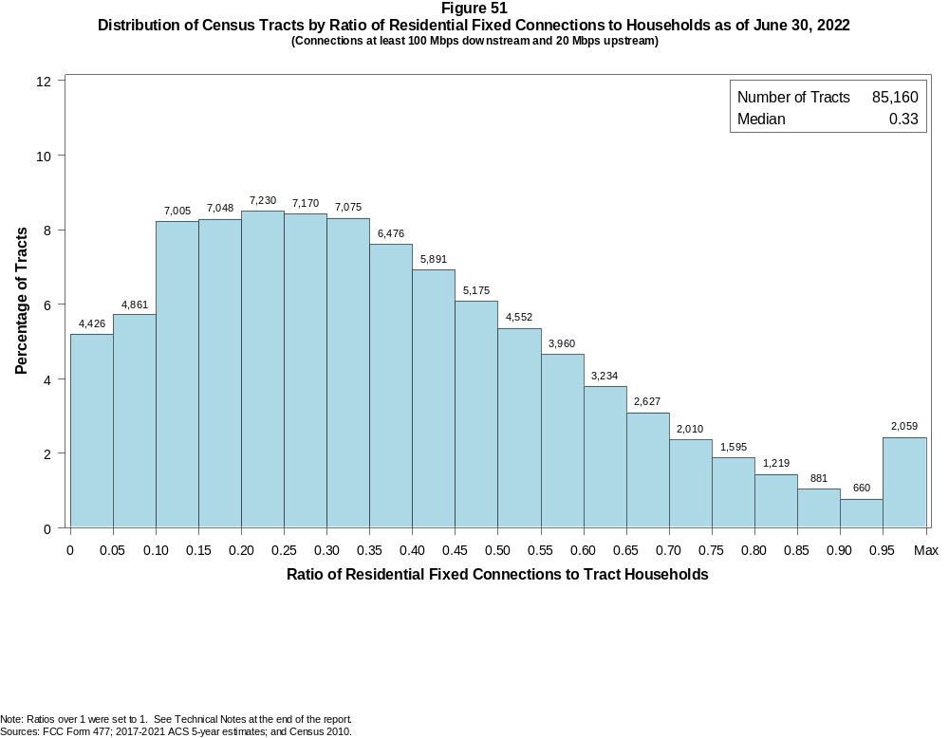

Figure 52
Distribution of Census Tracts by Ratio of Residential Fixed Connections to Households by Technology as of June 30, 2022
(Connections at least 100 Mbps downstream and 20 Mbps upstream)

 | Ratio of Residential Fixed Connections to Tract Households
Technology | Zero | Greater than 0 and no more than 5% | Greater than 5 and no more than 10% | Greater than 10 and no more than 20% | Greater than 20 and no more than 30% | Greater than 30 and no more than 40% | Greater than 40 and no more than 50% | Greater than 50 and no more than 60% | Greater than 60 and no more than 80% | Greater than 80 and no more than 100% | 100% or more
Total | 1.3 | 3.9 | 5.7 | 16.5 | 16.9 | 15.9 | 13.0 | 10.0 | 11.1 | 3.7 | 2.0
Copper Wire¹ | 62.9 | 34.2 | 2.1 | 0.6 | 0.0 | 0.0 | 0.0 | 0.0 | 0.0 | 0.0 | 0.0
Coaxial Cable | 7.1 | 6.1 | 10.2 | 30.4 | 23.7 | 11.6 | 5.4 | 2.7 | 2.0 | 0.5 | 0.3
Optical Carrier | 29.0 | 19.5 | 9.5 | 14.0 | 10.2 | 7.1 | 4.5 | 2.5 | 2.3 | 0.8 | 0.6
Satellite | 54.4 | 44.4 | 0.8 | 0.3 | 0.1 | 0.0 | 0.0 | 0.0 | 0.0 | 0.0 | 0.0
Fixed Wireless | 69.6 | 29.2 | 0.6 | 0.3 | 0.1 | 0.0 | 0.0 | 0.0 | 0.0 | 0.0 | 0.0
Licensed | 74.0 | 25.5 | 0.3 | 0.1 | 0.0 | 0.0 | 0.0 | 0.0 | 0.0 | 0.0 | 0.0
Unlicensed | 93.6 | 5.7 | 0.3 | 0.2 | 0.1 | 0.0 | 0.0 | 0.0 | 0.0 | 0.0 | 0.0
¹ Other is summarized with Copper Wire for confidentiality reasons. See Technical Notes at the end of the report for a description of FCC Form 477 technology categories and other reporting requirements.
Note: Numbers may not sum to totals due to rounding.
Sources: FCC Form 477; 2017-2021 ACS 5-year estimates; and Census 2010.

Figure 53
Distribution of Census Tracts by Ratio of Residential Fixed Connections to Households by State as of June 30, 2022
(Connections at least 100 Mbps downstream and 20 Mbps upstream)

 |  | Ratio of Residential Fixed Connections to Tract Households
State | Tracts | Zero | Greater than 0 and no more than 5% | Greater than 5 and no more than 10% | Greater than 10 and no more than 20% | Greater than 20 and no more than 30% | Greater than 30 and no more than 40% | Greater than 40 and no more than 50% | Greater than 50 and no more than 60% | Greater than 60 and no more than 80% | Greater than 80 and no more than 100% | 100% or more
Alabama | 1,435 | 8 | 128 | 134 | 274 | 287 | 190 | 144 | 124 | 106 | 29 | 11
Alaska | 177 | 29 | 17 | 7 | 5 | 7 | 15 | 18 | 30 | 39 | 6 | 4
American Samoa | 18 | 18 | 0 | 0 | 0 | 0 | 0 | 0 | 0 | 0 | 0 | 0
Arizona | 1,765 | 34 | 151 | 231 | 555 | 362 | 172 | 85 | 58 | 79 | 24 | 14
Arkansas | 823 | 6 | 111 | 89 | 165 | 132 | 95 | 77 | 56 | 70 | 18 | 4
California | 9,107 | 67 | 110 | 190 | 1,278 | 2,309 | 2,289 | 1,531 | 767 | 425 | 81 | 60
Colorado | 1,447 | 18 | 40 | 65 | 287 | 426 | 307 | 161 | 65 | 51 | 15 | 12
Connecticut | 879 | 7 | 2 | 6 | 106 | 131 | 108 | 139 | 141 | 136 | 89 | 14
Delaware | 259 | 3 | 0 | 1 | 3 | 13 | 23 | 48 | 57 | 66 | 27 | 18
District of Columbia | 206 | 2 | 0 | 0 | 1 | 19 | 39 | 36 | 33 | 55 | 11 | 10
Florida | 5,114 | 48 | 137 | 176 | 517 | 836 | 978 | 861 | 621 | 566 | 211 | 163
Georgia | 2,791 | 11 | 94 | 151 | 293 | 365 | 396 | 417 | 404 | 488 | 139 | 33
Guam | 56 | 18 | 35 | 1 | 1 | 0 | 0 | 0 | 0 | 0 | 0 | 1
Hawaii | 436 | 22 | 2 | 5 | 23 | 67 | 85 | 79 | 54 | 63 | 17 | 19
Idaho | 456 | 0 | 17 | 25 | 56 | 47 | 57 | 91 | 70 | 70 | 11 | 12
Illinois | 3,263 | 7 | 83 | 84 | 365 | 786 | 832 | 612 | 332 | 143 | 15 | 4
Indiana | 1,693 | 10 | 51 | 84 | 214 | 358 | 409 | 286 | 137 | 119 | 16 | 9
Iowa | 896 | 4 | 27 | 60 | 142 | 248 | 173 | 87 | 70 | 71 | 14 | 0
Kansas | 829 | 15 | 42 | 145 | 143 | 119 | 67 | 66 | 66 | 114 | 42 | 10
Kentucky | 1,306 | 11 | 72 | 129 | 233 | 211 | 206 | 164 | 141 | 106 | 23 | 10
Louisiana | 1,376 | 16 | 177 | 193 | 282 | 201 | 205 | 128 | 89 | 66 | 14 | 5
Maine | 400 | 0 | 1 | 42 | 253 | 52 | 23 | 15 | 10 | 4 | 0 | 0
Maryland | 1,463 | 8 | 7 | 5 | 33 | 112 | 205 | 259 | 248 | 369 | 136 | 81
Massachusetts | 1,613 | 22 | 4 | 10 | 144 | 101 | 196 | 267 | 319 | 387 | 101 | 62
Michigan | 2,971 | 82 | 88 | 218 | 644 | 631 | 672 | 433 | 134 | 58 | 9 | 2
Minnesota | 1,502 | 4 | 52 | 103 | 528 | 351 | 178 | 114 | 60 | 88 | 19 | 5
Mississippi | 875 | 8 | 129 | 55 | 135 | 129 | 107 | 98 | 83 | 103 | 20 | 8
Missouri | 1,654 | 14 | 172 | 111 | 216 | 250 | 258 | 204 | 177 | 185 | 43 | 24
Montana | 319 | 3 | 22 | 63 | 147 | 38 | 7 | 8 | 11 | 14 | 5 | 1
Nebraska | 553 | 2 | 20 | 55 | 128 | 105 | 70 | 59 | 66 | 38 | 8 | 2

Figure 53 - Continued
Distribution of Census Tracts by Ratio of Residential Fixed Connections to Tract Households by State as of June 30, 2022
(Connections at least 100 Mbps downstream and 20 Mbps upstream)

 |  | Ratio of Residential Fixed Connections to Tract Households
State | Tracts | Zero | Greater than 0 and no more than 5% | Greater than 5 and no more than 10% | Greater than 10 and no more than 20% | Greater than 20 and no more than 30% | Greater than 30 and no more than 40% | Greater than 40 and no more than 50% | Greater than 50 and no more than 60% | Greater than 60 and no more than 80% | Greater than 80 and no more than 100% | 100% or more
Nevada | 775 | 5 | 23 | 56 | 252 | 211 | 106 | 50 | 29 | 25 | 8 | 10
New Hampshire | 349 | 2 | 3 | 8 | 25 | 24 | 38 | 67 | 95 | 54 | 13 | 20
New Jersey | 2,175 | 14 | 15 | 9 | 38 | 101 | 114 | 220 | 411 | 810 | 285 | 158
New Mexico | 612 | 17 | 78 | 151 | 221 | 62 | 33 | 20 | 8 | 13 | 6 | 3
New York | 5,393 | 140 | 30 | 248 | 931 | 443 | 402 | 427 | 657 | 1,336 | 541 | 238
North Carolina | 2,660 | 22 | 87 | 166 | 550 | 454 | 371 | 303 | 248 | 284 | 100 | 75
North Dakota | 228 | 1 | 0 | 0 | 7 | 9 | 7 | 16 | 20 | 71 | 74 | 23
Northern Mariana Isl | 23 | 23 | 0 | 0 | 0 | 0 | 0 | 0 | 0 | 0 | 0 | 0
Ohio | 3,162 | 44 | 189 | 354 | 872 | 618 | 483 | 285 | 178 | 119 | 16 | 4
Oklahoma | 1,205 | 22 | 114 | 111 | 225 | 224 | 196 | 121 | 86 | 71 | 24 | 11
Oregon | 994 | 2 | 7 | 56 | 324 | 216 | 171 | 147 | 45 | 17 | 7 | 2
Pennsylvania | 3,445 | 64 | 81 | 92 | 262 | 364 | 587 | 647 | 490 | 566 | 200 | 92
Puerto Rico | 939 | 38 | 202 | 236 | 284 | 108 | 43 | 13 | 11 | 1 | 1 | 2
Rhode Island | 247 | 1 | 0 | 2 | 24 | 6 | 32 | 82 | 48 | 41 | 6 | 5
South Carolina | 1,317 | 15 | 62 | 121 | 226 | 222 | 198 | 140 | 100 | 121 | 51 | 61
South Dakota | 242 | 0 | 11 | 6 | 31 | 21 | 10 | 18 | 23 | 78 | 36 | 8
Tennessee | 1,701 | 24 | 36 | 54 | 271 | 257 | 260 | 267 | 214 | 223 | 69 | 26
Texas | 6,883 | 63 | 292 | 329 | 871 | 847 | 1,029 | 1,012 | 841 | 1,036 | 370 | 193
Utah | 716 | 7 | 8 | 25 | 92 | 150 | 152 | 92 | 66 | 78 | 36 | 10
Vermont | 193 | 1 | 4 | 13 | 22 | 35 | 43 | 30 | 21 | 12 | 3 | 9
Virgin Islands | 29 | 25 | 4 | 0 | 0 | 0 | 0 | 0 | 0 | 0 | 0 | 0
Virginia | 2,186 | 35 | 117 | 61 | 294 | 273 | 280 | 288 | 272 | 314 | 155 | 97
Washington | 1,772 | 5 | 29 | 88 | 408 | 551 | 357 | 210 | 80 | 28 | 7 | 9
West Virginia | 546 | 15 | 80 | 32 | 56 | 80 | 97 | 75 | 63 | 46 | 2 | 0
Wisconsin | 1,526 | 4 | 81 | 204 | 516 | 395 | 171 | 78 | 42 | 24 | 4 | 7
Wyoming | 160 | 1 | 1 | 14 | 86 | 32 | 10 | 5 | 7 | 3 | 1 | 0
Total | 85,160 | 1,087 | 3,345 | 4,874 | 14,059 | 14,396 | 13,552 | 11,100 | 8,478 | 9,450 | 3,158 | 1,661
Note: Numbers may not sum to totals due to rounding. See Technical Notes at the end of the report.
Sources: FCC Form 477; 2017-2021 ACS 5-year estimates (Households for U.S. and District of Columbia); Census 2010 (Households for Puerto Rico, American Samoa,
Guam, Northern Mariana Islands and U.S. Virgin Islands).

